The Arrive & Thrive! Program

Improving Access to Quality Maternal and Neonatal Health Care in
Akyem Dwenase, Eastern Region, Ghana

Project Partners:
Friends of Dwenase
Akyem Dwenase Health Committee
Akyem Dwenase Health Centre

Project Consultants:
Mayah Burgess
Dorian Burks
Dielle Lundberg
Martina Spain

Boston University School of Public Health
May 31, 2019

Table of Contents

- Acronym List……………………………………………………………………………………………………….3
- Executive Summary……………………………………………………………………………………………….4
- Situation Analysis………………………………………………………………………………………………….5
- Technical Plan……………………………………………………………………………….………………….....8
  - Logic Model………………………………………………………………………………………………..9
  - Goals and Objectives…………………………………………………………………………………...10
  - Gantt Chart Visual Summary…………………………………………………………………………..10
  - Management Structure………………………………………………………….……………………...14
  - Organization Chart………………………………………………………………………………………14
- Monitoring and Evaluation Plan………………………………………………………………………………...15
- Budget Narrative…………………………………………………………………………………………………17
- Sustainability Plan……………………………………………………………………………………………….18
- Capability Statement…………………………………………………………………………………………….19
- Annexes…………………………………………...……………………………………………………………...20
  - Organizational Map of Ghanaian Health Care System………………………………………...….. 20
  - Health Centre Staff Interview Summary………………………………………………………………21
  - Survey of Health Centre Staff………………………………………………………………………….22
  - Gantt Chart………………………………………………………………………………………………24
  - M&E Indicators Table…………………………………………………………………………………...25
  - Low-Dose High-Frequency Training Description…………………………………………………….28
  - Budget…………………………………………………………………………………………………....29
  - Budget Justification……………………………………………………………………………………..30
  - Recommendations for Funding Strategy……………………………………………………………..32
  - External Review Feedback……………………………………………………………………………..33

I. Acronym List

ANC …………………. Antenatal Care
BEmONC……………. Basic Emergency Obstetric and Neonatal Care
CHW…………………..Community Health Worker
EmONC …………….. Emergency Obstetric and Neonatal Care
FoD…………………...Friends of Dwenase
LDHF………………....Low-Dose High-Frequency
MCH ………………… Maternal and Child Health
M&E…………………..Monitoring and Evaluation
MoH …………………. Ministry of Health
NGO…………………..Non-Governmental Organization
NHIS ………………… National Health Insurance Scheme
SMS …………………. Short Message Service (text)
SOPs …………………Standard Operating Procedures
WHO ………………… World Health Organization

II. Executive Summary

Friends of Dwenase is a non-governmental organization (NGO) whose mission is to improve health outcomes in the rural town of Akyem Dwenase in the Eastern Region of Ghana, starting by addressing the needs of the Akyem Dwenase Health Centre. This Health Centre serves the 3,000 residents of the town, in addition to those living in surrounding communities. Often, patients travel up to an hour across rough terrain to reach the Health Centre. If there is a complication, the patient is then referred to the District Hospital, which is another hour away. The Health Centre has an inconsistent supply of medicine and supplies, and the staff is not fully trained to perform basic emergency maternal and neonatal care (BEmONC). These challenges emphasize two of the most common delays in accessing maternal and neonatal health care: delays in reaching the health facility and delays in receiving adequate care.

In Ghana, the maternal mortality rate is 310 deaths per 100,000 live births. Most of these deaths are related to hemorrhage, hypertensive disorders, infections, and obstructed labor. This is lower than the average mortality rate in sub-Saharan Africa but higher than most countries around the world. For example, in the United States, maternal mortality is 26 deaths per 100,000 live births. The average rate for high-income countries is 12 deaths per 100,000 live births. In the Eastern Region of Ghana, neonatal mortality is 28 deaths per 1,000 live births.

The Arrive & Thrive! Program aims to ensure that every woman and child in the greater Akyem Dwenase community will have access to quality obstetric and neonatal health care by addressing the two delays mothers commonly face. This will be accomplished through three main objectives:

Objective 1: By the end of Year 1, 95% of currently pregnant women in Akyem Dwenase proper and women in the greater community who have made initial contact with the health centre will be using the Rapid SMS-MCH alert and emergency planning systems to reduce delays in pregnancy complication treatment. This involves the implementation of a Rapid SMS-MCH Alert System, emergency planning, and an emergency transport system.

Objective 2: By the end of Year 2, all clinical staff at the Akyem Dwenase Health Centre will be able to provide quality BEmONC. This objective focuses on the creation of standard operating procedures (SOPs) for the health centre, in addition to providing on-site low-dose high-frequency (LDHF) trainings and simulations on BEmONC.

Objective 3: By the end of Year 3, the Akyem Dwenase Health Centre will be equipped to provide the 7 signal functions of a basic emergency obstetric care facility. This includes expanding the maternity ward of the health centre and putting systems in place to ensure the health centre has necessary equipment and medical supplies to provide basic emergency care.

The Arrive & Thrive! Program was carefully designed for sustainability, with many elements being one time capacity, capability, and implementation costs. Program components that increase sustainability include training trainers, maintaining diverse funding streams, and having significant buy-in at the community and clinic level. Friends of Dwenase’s founder is Akyem Dwenase Chief, Osabarima Owusu Baafi Aboaykye III. The Chief’s involvement will support continuity in the program leadership and ensure accountability for program outcomes.

Friends of Dwenase is requesting $97,950.72 in order to design and implement the Arrive & Thrive! Program. Your support for this project will help community leaders and health workers achieve their vision for providing women and children in the Akyem Dwenase community with access to quality obstetric and neonatal care.
III. Situation Analysis
Introduction
In the rural town of Akyem Dwenase in the Eastern Region of Ghana, one health center with a single delivery bed provides maternal and neonatal care to pregnant women living within a ten kilometer radius. The town’s population is 3000 residents, yet patients from nearby communities travel here by car, bus, and foot. As a result, the center often runs out of supplies. The delivery room is the size of a small office, and if more than two mothers go into labor at once, the midwife is forced to move one mother and her newborn to the floor. Staffed by a physician assistant, a midwife, and nurses, the clinic is not equipped to provide emergency obstetric care. In the event of a complication, the closest district hospital is located over one hour away by taxi. The patient and their family are responsible for arranging and paying for their own transportation to the District Hospital.
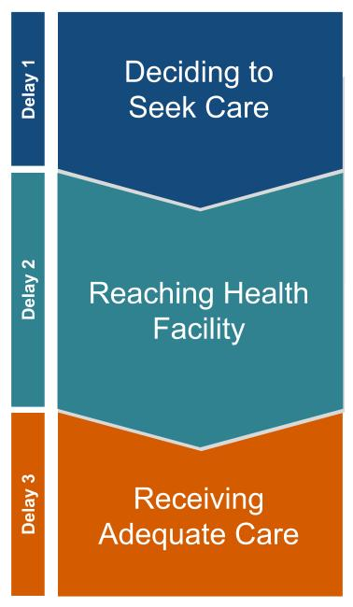
Kwabena Kyei-Aboagye is a lawyer and professor of urban planning at Boston University, who was recently appointed Chief, and given the name Osabarima Owusu Baafi Aboaykye III of Akyem Dwenase (hereafter referred to as Osabarima Owusu Baafi Aboaykye III). He views his new leadership role in the community as a unique opportunity to take action on the social and environmental justice issues that he has researched over the last twenty years of his career. In 2019, he founded Friends of Dwenase, a NGO with a mission to improve health outcomes in the town and neighboring areas. In its first year, Friends of Dwenase seeks to launch a 3-year plan for improving maternal and neonatal health by building on the strengths of the Akyem Dwenase Health Centre and addressing the challenges it faces.
Figure 1. 3-Delay Model
Three Delays that Influence Maternal and Neonatal Mortality
Around the world, three sets of factors are known to delay access to maternal and neonatal health care. In the Eastern Region of Ghana, 97% of mothers decide to seek care of some kind. However, in Akyem Dwenase, mothers often encounter a delay in reaching the Health Centre at the time of delivery due to a lack of reliable transport and emergency planning. They also experience a delay in receiving adequate and appropriate treatment at the Health Centre in the event of any birth complications. Due to a lack of supplies, training, and equipment, staff are forced to transfer mothers with experiencing complications to the District Hospital almost an hour away. Both delays are threats to the life of the mother and newborn(s) (Figure 1).
Maternal and Neonatal Mortality in Ghana
Ghana is a lower-middle income nation in West Africa with a population of over 26 million. More than 500,000 children are born in Ghana every year. Maternal mortality refers to women who die during pregnancy, delivery, or 42 days after the end of pregnancy. Since the late 1990s, maternal mortality in Ghana has decreased from 740 deaths per 100,000 live births in 1997 to 310 deaths per 100,000 live births in 2017 (Table 1).

Table 1. Comparison of Maternal and Neonatal Mortality by Location

Country | Maternal Mortality (1997) | Maternal Mortality (2017) | Neonatal Mortality (2017)
Ghana | 740 per 100,000 | 310 per 100,000 | 25 per 1,000
Eastern Region | - | - | 28 per 1,000
Sub-Saharan Africa | 901 per 100,000 | 547 per 100,000 | 27 per 1,000
Maternal and Neonatal Mortality in Eastern Region, Ghana
Increasing antenatal care (ANC) and access to skilled birth attendants have been important tools in reducing maternal mortality in Ghana. Despite these improvements, maternal mortality remains high in Ghana compared to other countries. 67% of maternal deaths are attributed to direct maternal causes including hemorrhage, unsafe abortion, hypertensive disorders, infections, and obstructed labor. Logistic and financial challenges such as transportation, cost, and quality of care at facilities contribute greatly to these deaths. Alongside trends in maternal mortality, the infant and under-5 mortality rates in Ghana have decreased 52% and 66.5% over the last two decades. However, the national neonatal mortality rate has remained relatively stagnant since 2007. In the Eastern Region, neonatal mortality is 28 deaths per 1,000 live births, which is higher than other regions.
The World Health Organization recommends a minimum of 4 ANC visits for pregnant women. As of 2017, 97% of women in the Eastern Region aged 15-49 received 4 or more ANC visits. Additionally, 79% of deliveries occurred at health facilities. Sixteen percent of deliveries were assisted by doctors while 64% were assisted by nurses, midwives, or community health officers. Eighty-six percent of newborns received a postnatal check within two days of delivery, and 70% had a postnatal check in the first hour.
Maternal and Child Health (MCH) Care in Eastern Region, Ghana
Figure 2. Map of Ghana
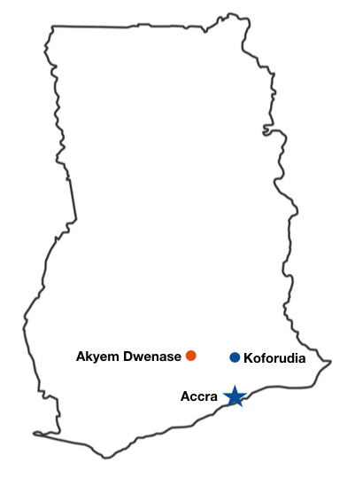
Ghana established a universal health care system through its National Health Insurance Scheme (NHIS) in 2003. The NHIS pays for health services at the country’s tertiary hospitals, district hospitals, community health centers, and pharmacies (Annex A). Health care facilities and policies are regulated by the national Ministry of Health (MoH). In 2008, the government implemented a free maternal health policy within the NHIS. This policy aims to help pregnant women register for insurance to receive free antenatal and postnatal care. Today, most women receive ANC visits in Ghana. However, more than half of women report that they are asked to pay out-of-pocket for prenatal care visits, at the time of delivery, and for postnatal care visits due to a lack of funds at facilities.
In the Eastern Region of Ghana, the MoH is based in the regional capital of Koforudia, which is approximately two hours away from the Denkyembour District where Akyem Dwenase is located (Figure 2). The District Hospital is 20 kilometers from town. This hospital has 320 beds and is equipped to provide comprehensive emergency obstetric care including deliveries by cesarean section and blood transfusions.
Social Determinants of Health in Akyem Dwenase
The Eastern Region of Ghana is largely rural. Due to a lack of health care and transportation infrastructure, rural areas have worse maternal and neonatal health outcomes than urban areas. In the Denkyembour District, the primary sources of employment are farming and gold or diamond mining. Illegal mining is common among youth with limited economic opportunities. In Akyem Dwenase, 38% of the population is under the age of 14, and most adults are less than 30 years old. The town has a primary and junior high school (Figure 3). However, very few students reportedly pass their standardized exams to enter secondary school. Despite these challenges, local leaders are committed to revitalizing the area through infrastructure building. In the area, most households have a cell phone, and the town has 4G service. Electricity is also relatively stable. The central role of family and the role of churches as community-builders may serve as protective factors for health.
Figure 3. School in Akyem Dwenase, Ghana Figure 4. Health Centre in Akyem Dwenase, Ghana
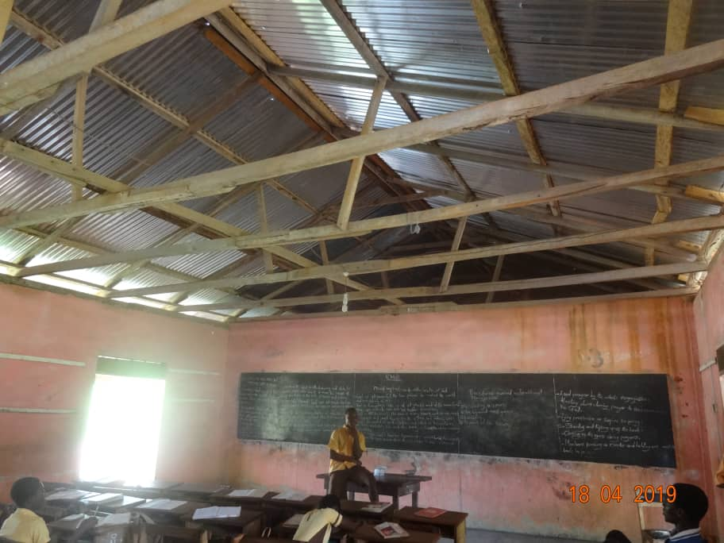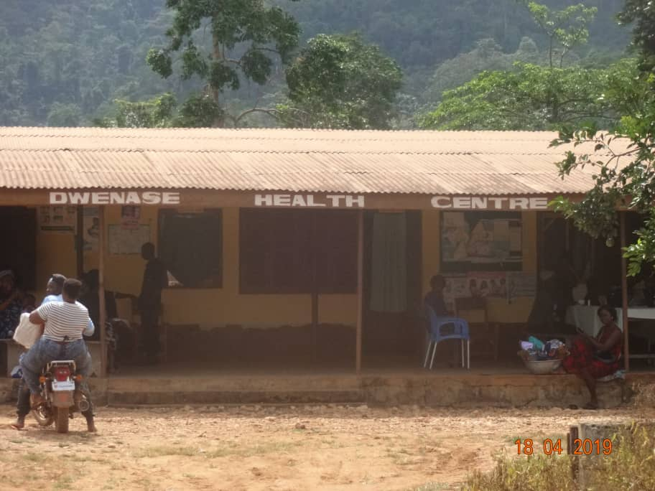

Historical and Socio-Political Context of U.S.-Funded Public Health Programs in Ghana
The challenges faced by the Akyem Dwenase Health Centre (Figure 4) in 2019 have been shaped by the colonial and post-colonial history of Ghana. Ghana became an independent nation in 1956 after more than a century of forced occupation by Britain. During this time, Britain and the United States built their present-day economic power using natural resources from Ghana and the labor of West African slaves. At the same time, colonial powers and missionaries in Ghana worked to dismantle traditional cultural, education, and health systems in Ghana and impose new systems with a goal of reducing African autonomy at the community-level.
Kwame Nkrumah, the first president of Ghana, coined the term neo-colonialism to describe efforts by the United States and Britain to continue undermining the sovereignty of African communities and governments through aid, trade, and investment under the guise of poverty reduction. The effects of neo-colonialism are seen in many NGOs, public health institutions, and foundations. As we undertake this work, we must be cognizant of this history and work to amplify the voices of our local partners.
Positionality and Methods of Project Consultants
This proposal was generated by a team of 4 graduate students in the Master of Public Health program at Boston University School of Public Health as part of a two-week intensive program design course. Our team offered expertise in MCH, community assessment and program design, and health equity research. One of the consultants had prior experience working with a community health center in Guatemala on a MCH project. Another consultant had previously worked with NGOs in urban Ghana. None of the consultants were Ghanaian, Ghanaian-American, or had previously visited the town of Akyem Dwenase. As a result, we as consultants must recognize that we are outsiders to this program’s context. The lived experience of the mothers, health workers, and community leaders in Akyem Dwenase are not our own. We consider the local stakeholders in this program to be the experts.
Thus, our mission was foremost to listen to the experiences of our colleagues in Ghana who work at the Akyem Dwenase Health Centre, identify their priorities and vision, and communicate these to program leadership. Our efforts to listen included conversations through WhatsApp calls and messages, a survey, and receiving written responses to our questions. In building this proposal, we sought to identify and share evidence-based program activities that have been previously implemented in Ghana and other sub-Saharan African contexts.

IV. Technical Plan
Program Summary
The Arrive & Thrive! Program aims for every woman and child in the greater Akyem Dwenase community to have access to quality obstetric and neonatal health care. This includes improving the quality of care and patient experience for pregnant women and their newborns as well as improving access to the Health Centre and District Hospital for pregnant women. These long term outcomes will be accomplished by expanding the facility, improving supplies of essential medicine and equipment, increasing personnel within the Health Centre, and providing BEmONC training for the clinical staff. There will also be a reduction in the time it takes for pregnant women to arrive at both the Health Centre and District Hospital through the use of an emergency transportation network and SMS alert system.
These outcomes will require participation from the Akyem Dwenase Health Centre staff and the Health Committee as well as community members, particularly mothers and pregnant women. Activities involved in this proposal can be divided into two main categories: staff capacity and infrastructure. With regard to staff capacity and training, SOPs will be developed, additional medical equipment and supplies will be purchased, and the staff will be expanded and provided BEmONC training. Activities related to improving the infrastructure of the Health Centre include designing and building an expanded maternity ward and developing a Rapid SMS-MCH Alert System and emergency transportation network.
Program resources, activities, outcomes, and impacts are summarized in the logic model (Figure 5).

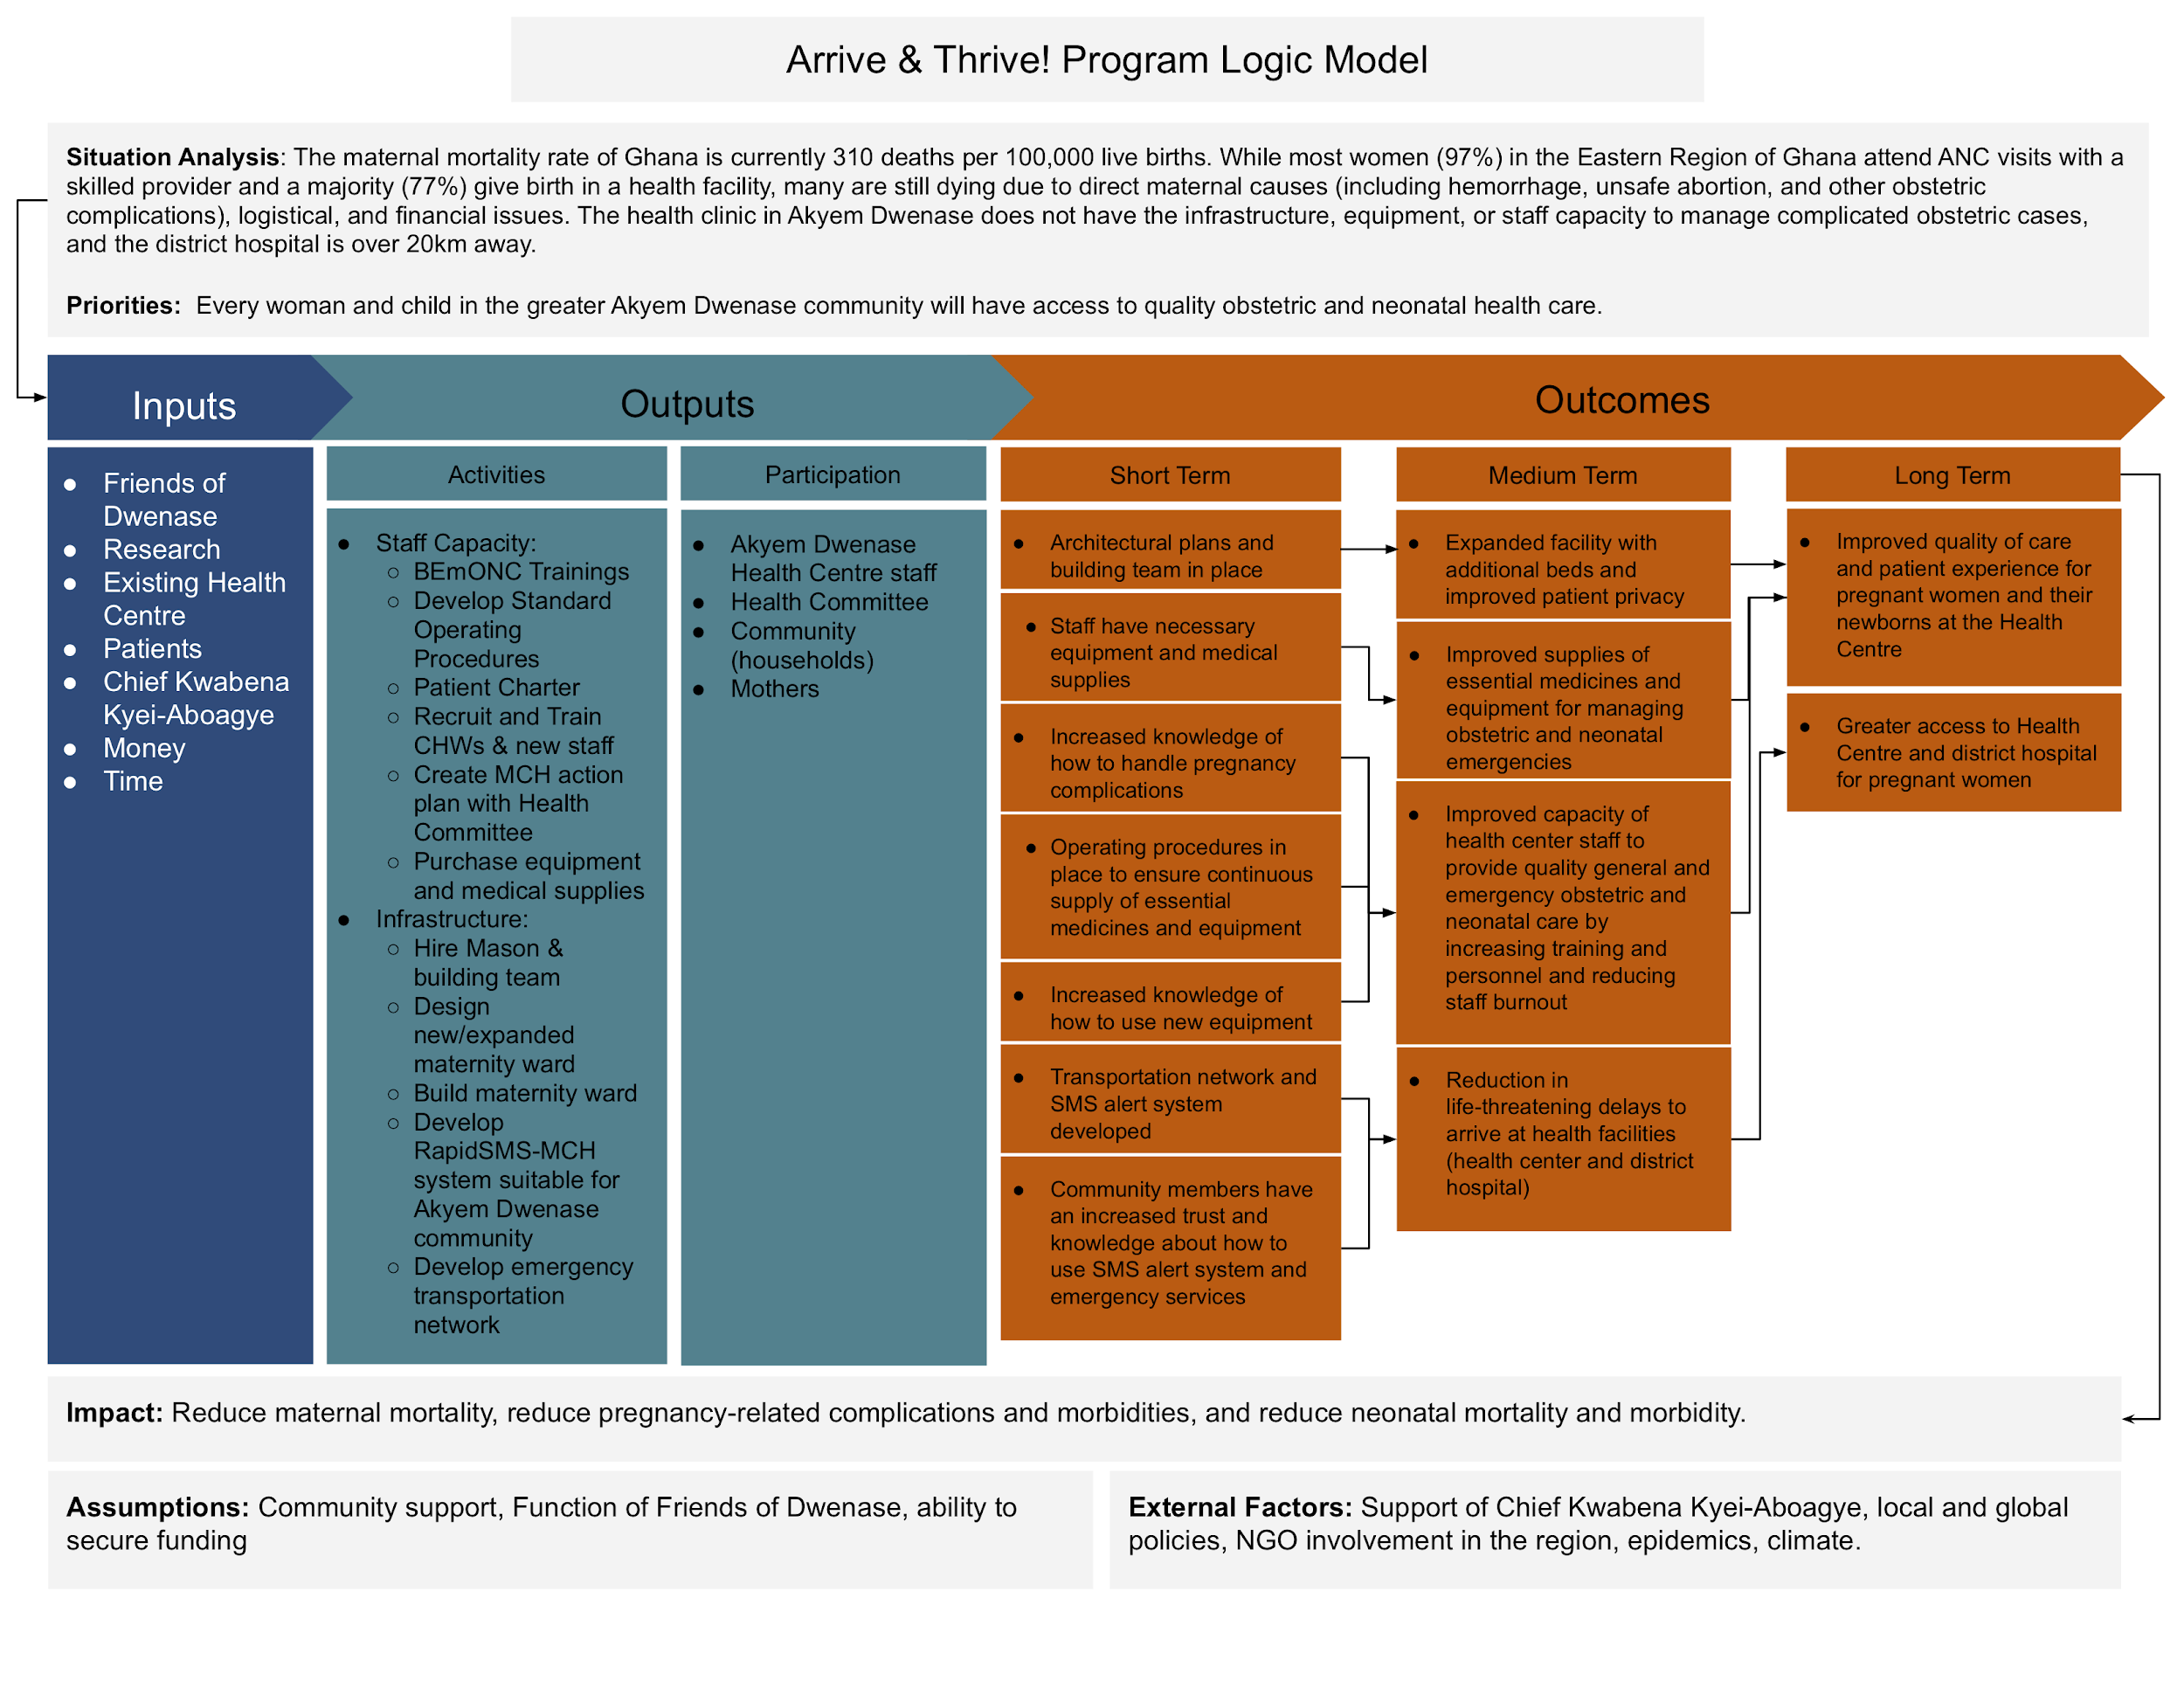
Figure 5. Arrive & Thrive! Program Logic Model
Goal and Objectives
Program Goal
Through the Arrive & Thrive! Program, our goal is to ensure that every woman and child in the greater Akyem Dwenase community will have access to quality obstetric and neonatal health care. We built our theory of change around the three delays of accessing maternal care, which attribute three major factors to decreased access: 1) delays in the decision to seek care, 2) delays in reaching care, and 3) delays in receiving adequate health care (Figure 1). In Akyem Dwenase, the main barriers to access relate most closely to the second and third delays, as seen in our program’s three objectives.
Overview of Program Objectives
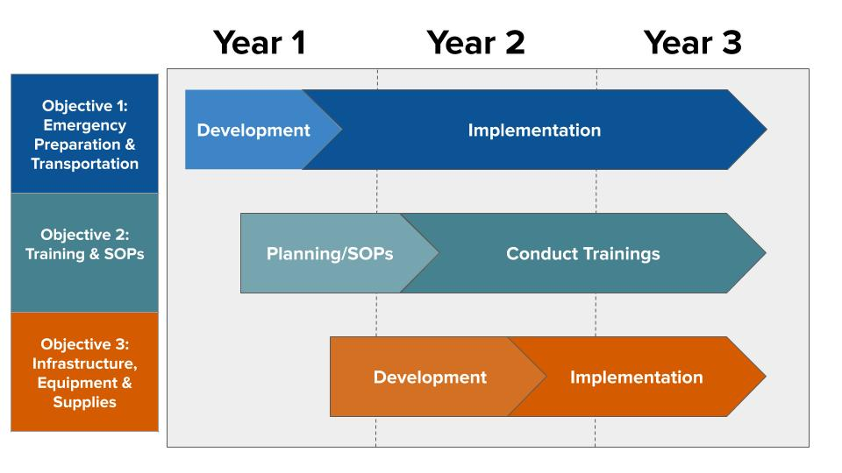
- By the end of Year 1, 95% of currently pregnant women in Akyem Dwenase proper and women in the greater community who have made initial contact with the Health Centre will be using the Rapid SMS-MCH alert and emergency planning systems to reduce delays in pregnancy complication treatment.
- By the end of Year 2, all clinical staff at the Akyem Dwenase Health Centre will be able to provide quality BEmONC.
- By the end of Year 3, the Akyem Dwenase Health Centre will be equipped to provide the 7 signal functions of a basic emergency obstetric care facility.
All three of these objectives are to be completed by the end of the third year of the program in accordance with our program timeline (Figure 6).
Figure 6. Program Timeline
Program Objective #1
Objective
By the end of Year 1, 95% of currently pregnant women in Akyem Dwenase proper and women in the greater community who have made initial contact with the Health Centre will be using the Rapid SMS-MCH alert and emergency planning systems to reduce delays in pregnancy complication treatment.
Activities
In order to meet Objective #1, we propose focus on three phased activities: the contextualization and implementation of the Rapid SMS-MCH alert system, the incorporation of emergency planning in ANC visits, and the development of a more robust emergency transport system.
Rapid SMS-MCH Alert System: An SMS-based alert system has been successfully used for widespread improvement of pregnancy monitoring and emergency care in Rwanda. The program is prime for contextualization in other low-resource settings, and seems well suited for addressing Akyem Dwenase’s rural challenges and utilizing its resource of a strong cellular network. Initially, program staff consult with the implementers of the model to understand their implementation model, and simultaneously recruit a programmer who can adapt the SMS scripts for the Akyem Dwenase setting. The program staff and programmer will work to adapt and pilot the SMS alert system to link Health Centre staff and additional CHWs recruited from the community to remind and follow-up on ANC visits. As the emergency transport system, described below, is established, the SMS alert system will also link with these drivers to coordinate alerts and transportation.
Emergency Planning: As administrative burden for ANC visit reminders and follow-up is reduced with the introduction of the Rapid SMS-MCH alert system, Health Centre staff and peer educators will be able to begin an emergency planning protocol with pregnant mothers during their first ANC visits. This will be evaluated through mothers reviewing and teaching back this protocol during subsequent ANC visits.
Emergency Transport System: The success of the above elements in large part relies on the availability of reliable and speedy transportation of pregnant women to the Health Centre. In order to more deeply understand and address these transportation issues, within the three months of the program the program staff will convene a focus group of women in the greater Akyem Dwenase community who have accessed services at the clinic to understand and map their current transportation options and major issues. With this focus group, program staff will co-design an emergency transportation system, in collaboration with community members with cars, with the potential of creating an “on-call” taxi service. The staff will research the feasibility of motorcycle ambulances and other methods to withstand heavy rain, considering community resources and additional funding if necessary. By the end of Year 1, program staff will work to incorporate this improved system with the Rapid SMS-MCH alert system.
Program Model
The Rapid SMS-MCH Alert System is outlined by Fidele Ngabo et al. in a 2012 research article in The Pan African Medical Journal, titled “Designing and Implementing an Innovative SMS-based alert system (RapidSMS-MCH) to monitor pregnancy and reduce maternal and child deaths in Rwanda,” PMCID: PMC3542808.

Program Objective #2
Objective
By the end of Year 2, all clinical staff at the Akyem Dwenase Health Centre will be able to provide quality BEmONC.
Activities
In order to fulfill Objective #2, we propose the implementation of two key components: SOPs, and clinical staff trainings on BEmONC.
SOPs: An important first step will be developing SOPs for general obstetric and neonatal care. The staff of the Akyem Dwenase Health Centre will be primarily responsible for creating these SOPs, and they will be able to utilize them in their everyday care, ensuring efficient and effective procedures.
Training: A LDHF model will be utilized to increase Health Centre staff knowledge and competency in providing BEmONC. All Health Centre staff and CHWs who provide labor, delivery, and immediate postpartum care will attend LDHF trainings on BEmONC. Two LDHF Trainers will collaborate with the Akyem Dwenase Health Clinic Director to adapt LDHF trainings to the local context, plan trainings, and identify mentors to provide high-frequency mentorship to Trainees. Two 4-day onsite trainings will take place at the Akyem Dwenase Health Centre: the first training (LDHF1) will focus on basic obstetric and neonatal care; the second training (LDHF2) will occur one month later, and focus on emergency and delivery complications for maternal and neonatal care. In collaboration with the MoH, the Health Centre staff will receive mentorship after the training sessions through individual phone calls, text messages, and quizzes from Mentors who are clinical staff employed by the MoH in comparable areas of Ghana. Overall, LDHF focuses on providing small amounts of content coupled with frequent repetition, interaction, and simulation-based practice. Annex F provides a more indepth look at the LDHF model that the Arrive & Thrive! Program plans to implement.
Program Model
This program model was adapted from the LDHF Program evaluated by Michelle Willcox, et al. in a 2017 research article in Globalization and Health, titled “Incremental cost and cost-effectiveness of low-dose, high-frequency training in basic emergency obstetric and newborn care as compared to status quo: part of a cluster-randomized training intervention evaluation in Ghana,” DOI:10.1186/s12992-017-0313-x.

Program Objective #3
Objective
By the end of Year 3, the Akyem Dwenase Health Centre will be equipped to provide quality obstetric and neonatal care and perform the seven signal functions of a basic emergency obstetric care facility.
Activities
To meet Objective 3, we propose activities that contribute to improvement in the capacity of the equipment, medical supplies, and infrastructure of the Akyem Dwenase Health Centre.
Equipment: The Akyem Dwenase Health Centre currently lacks basic supplies to provide quality basic obstetric and neonatal care, including multiple delivery beds, fetal doppler ultrasounds and heart rate monitors, manual vacuums, among others. We propose that Health Centre staff assess the current supply of equipment at the Health Centre, and identify what equipment is lacking but needed for BEmONC. We then propose that funding be allocated to the purchasing of necessary equipment. The Health Centre staff will be responsible for assessing and identifying equipment needs, and for the purchasing of the necessary equipment.
Medical supplies: A major burden for the Akyem Dwenase Health Centre is a lack of consistent medical supplies, disposable healthcare materials necessary for treatment, including medicines. This is due both to financial need and supply chain issues. The Health Centre clinical staff will collaborate with the MoH and the Arrive & Thrive! Program Director to identify supply chain issues, and will identify alternative means of obtaining the necessary medical supplies in case of shortages or delays in retrieving supplies. The Health Centre staff will develop a checklist of necessary supplies and a system to ensure that necessary supplies are consistently in stock. The stock of medical supplies and the alternative supply chain system will be evaluated yearly by Health Centre staff.
Infrastructure: To ensure that the Health Centre is able to provide the highest attainable quality of care to the mothers and children of Akyem Dwenase, the maternity ward must be expanded and improved to ensure privacy and capacity for a greater number of patients. We propose that Friends of Dwenase hire a local architect to work with women in the community and Health Centre staff to design and build an expanded maternity ward for the Health Centre. It is critical to involve patients in the design in an effort to center care around the patient experience. The architect will then work with volunteers from the greater Akyem Dwenase community to build the new maternity ward of the Health Centre.

Management Structure
The Arrive & Thrive! Program involves three different entities: the Friends of Dwenase, the MoH, and Osabarima Owusu Baafi Aboaykye III (Figure 7). Under the Friends of Dwenase NGO, there is an Arrive & Thrive! Program Director that is responsible for the M&E Technical Staff, the Rapid SMS-MCH Programmer and the Mason. The M&E Data Analyst will report to the M&E technical staff, while the Construction Workers and Electrician will report to the Mason responsible for the expansion of the maternity ward. The Community Volunteers are also involved in this construction project, and while they will be recruited by the Health Committee, they will primarily work under the direction of the construction workers. Osabarima Owusu Baafi Aboaykye III oversees the Akyem Dwenase Health Committee, which will help to find, recruit, and maintain community volunteers.
Also integral to the Arrive & Thrive! Program is partnership with the Ghanaian MoH. The Akyem Dwenase Health Centre Director reports to the MoH and is responsible for managing the Community Health Workers (CHWs) and the Akyem Dwenase Health Centre staff. The Health Centre staff are responsible for the Drivers that will be on-call as part of the Emergency Transportation Network. The BEmONC Trainer will primarily manage their own work and responsibilities; however, it is possible that the MoH will be able to provide additional financial support for this position.
Figure 7: Friends of Dwenase Arrive & Thrive! Program Organizational Structure
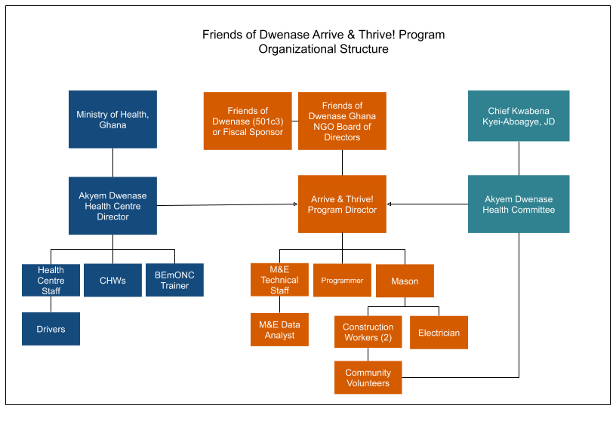

V. Monitoring and Evaluation (M&E) Plan
Overview of M&E Plan
The program’s M&E plan includes a mixed methods approach to track whether the Arrive & Thrive! Program is having the intended impact on the accessibility and quality of care and patient experience for the women of the greater Akyem Dwenase area. A detailed table of this plan is provided in Annex E.
Monitoring Plan
Through consistent measurement, we seek to answer our principal monitoring question: Was the Arrive & Thrive! Program implemented as outlined in the work plan? We will measure this program through the indicators described below. If challenges arise or changes need to be made, there is a system in place to address these concerns and adjust the program as needed.
Objective 1 focuses on implementing a Rapid SMS-MCH Alert System, emergency planning, and an emergency transport system. To monitor progress towards this objective, we will use a combination of qualitative patient surveys, focus groups, monthly SMS usage reports, and tracking of patients completing emergency plans at their ANC visits.
Objective 2 prioritizes the creation of SOPs and the providing of LDHF BEmONC training and simulations of complicated deliveries. This objective will be monitored using training attendance records, competency-based testing of Health Centre staff, and frequent check-ins from mentors through phone calls, text messages, and quizzes on BEmONC best practices.
Objective 3 involves improving the equipment, medical supplies, and infrastructure of the Health Centre, such that it will be fully equipped to provide quality BEmONC. To measure progress towards achieving this objective, we will rely on submission of documents from the Health Centre staff reporting on alternative supply chain solutions, essential medicine checklists, patient-centered design, and a building assessment. These measures are critical to ensuring that the Arrive & Thrive! Program is being executed within the allotted time frame and on track to having the intended outcomes.
Evaluation Plan
Further programmatic assessments at baseline, midline, and endline will seek to answer our principal evaluation question: Did implementation of the Arrive & Thrive! Program improve access to quality BEmONC for the women and children in the greater Akyem Dwenase area? Midline is considered to be 1.5 years after the initiation of the program. At this time, the Rapid SMS-MCH Alert System will already be in place and clinical staff training will be completed and mentorship will be in progress.
Objective 1 regarding the Rapid SMS-MCH Alert System and emergency planning and transport will be evaluated through qualitative baseline, midline, and endline assessments of patients’ confidence in their emergency plans, and community members’ perception of transportation to the Akyem Dwenase Health Centre and the District Hospital. This is key to measuring the reduction of the delays in arriving to the Akyem Dwenase Health Centre or District Hospital, and accessing care.
Objective 2 focused on clinical staff training and simulations and will be evaluated overall through staff knowledge, behaviors, and attitudes towards providing quality BEmONC, which will be measured at baseline and endline, and patients will be surveyed on their perception of the quality of care received.
Objective 3 regarding the Health Centre improvements to equipment, medical supplies, and infrastructure will be evaluated based upon the new maternity ward, which will be assessed through quantitative midline and endline assessments on equipment and infrastructure obtained and still needed to provide BEmONC, uptake of services in the new maternity ward, practice-based and qualitative evaluations of staff on their overall attitudes with regards to providing the seven signal functions of a BEmONC facility.
To perform the baseline, midline, and endline evaluations for each objective, the Arrive & Thrive! Program will hire a M&E Technical Consultant and a Data Analyst. The Technical Consultant will collect qualitative and quantitative evaluation data, and the Data Analyst will assist with cleaning and coding the data. Together, the Technical Consultant and Data Analyst will evaluate the data, and with the Arrive & Thrive! Program Director, they will create evaluation reports.
Limitations of M&E Plan
Potential limitations to the M&E plans include historical (socioeconomic) context, and funding. Given the socioeconomic context in Ghana, namely moving from low-income country status to a middle-income country status, programming in Ghana is not prioritized by international donors. If funding is limited and staff are not provided adequate funding, staff will not be motivated to follow monitoring procedures and M&E data will be inaccurate. Additionally, patients who visit the Health Centre are not randomly selected, or may be lost to follow up, and patient survey data may not accurately reflect the true patient experience. A final potential limitation to the evaluation is that the endline evaluation will occur close to the completion of the expanded maternity ward infrastructure project, which will limit the amount of data that can be collected to accurately measure improved access to quality BEmONC for women and children in the Akyem Dwenase area. This limitation could be addressed by extending funding for M&E beyond the program period to measure the impact of the Arrive & Thrive! Program on access to quality BEmONC.

VI. Budget Narrative

The total cost for the Arrive & Thrive! Program is $98,250.66 USD spread over the 3-year program duration. The majority of the budget will be allocated to personnel salaries, including a Arrive & Thrive! Program Director, CHWs, and On-Call Drivers. Contracted workers, including a M&E Specialist, Data Analyst, Rapid SMS-MCH Programmer, a Mason, Construction Workers and an Electrician, and two BEmONC Trainers and Mentors will be hired and paid at daily rates, totaling $1,613 over the program duration. The Mason will oversee the Maternity Ward Expansion project, for which the Arrive & Thrive! Program has allocated $14,926.81. Some staff and contracted employees are expected to travel within the Eastern Region, and others will be expected to travel internationally for Rapid SMS-MCH development. Travel and Per Diem have been allotted $27,453.60 throughout the program implementation period. Supplies, including medical supplies and equipment, and program implementation costs will total $20,706.77. The largest sum within this Supplies category is general obstetric and neonatal care and BEmONC supplies, many of which will be one-time payments to acquire supplies necessary to enable the Akyem Dwenase Health Centre staff to provide quality care.

A Summary of Budget Expenses is presented in Figure 8. The full Budget is presented in Annex G. A Budget Justification containing details for specific line items is included in Annex I.

Figure 8. Summary of Budget Expenses

Type of Expense | Year 1 | Year 2 | Year 3 | Total
Salaries | $7,650.00 | $7,956.00 | $6,002.88 | $21,608.88
Contracted Workers | $2,726.00 | $1,794.00 | $3,363.78 | $7,883.78
Benefits | $994.50 | $1,034.28 | $780.37 | $2,809.15
Operational  (Transport & Per Diem) | $8,510.00 | $9,074.00 | $9,869.60 | $27,453.60
Supplies | $3,350.00 | $7,914.40 | $9,442.37 | $3,350.00
Maternity Ward | $0.00 | $6,835.61 | $8,091.20 | $14,926.81
Total Costs | $23,927.42 | $35,646.54 | $38,676.70 | $98,250.66

VII. Sustainability Plan

The Arrive & Thrive! Program is carefully designed for sustainability, with many elements being one time capacity, capability, and implementation costs. The program will increase the ability of the Akyem Dwenase Health Centre to successfully take on more patients, creating a strong case for additional funding from the MoH.

The elements of the emergency planning and transport system include mostly upfront costs to bring in trainers and build the technical infrastructure for the Rapid SMS-MCH Alert System, which would then become self-sustaining. The Program Director would be responsible for the ongoing recruitment and management of drivers within the transport system. Within the first year of the program all elements of the system should be fully implemented, which would allow for two years of ongoing monitoring while the other components of the program are launched.

For the competency building component, the LDHF trainings and mentorship are specially designed for staff to retain knowledge and skills through simulation-based practice and participatory teaching methods. During these trainings led by the LDHF Trainers, Health Centre staff and CHWs will learn to coach and teach their peers in BEmONC. This will enable them to continue learning best practices and the frequent repetition of BEmONC themes in their clinical setting will allow them to successfully translate their lessons into their practice. Similarly, the Program Director will work with the Health Centre Director to create ongoing monitoring of adherence to the Standard Operating Processes, and accountability among the staff to adhere to the processes.

The Health Centre capacity improvement would be a one time augmentation of supplies and infrastructure. During the last 6 months of the program, the Program Director would create a risk assessment to determine the longevity of the equipment and what would be needed for the upkeep of the expanded Centre. This will be discussed with Health Centre staff and the Health Committee to implement contingency plans. Lastly, as the medical supply increase will be funded by the program, some funding will be set aside for the Program Director to conduct a supply chain analysis and create more proactive ordering processes. As the clinic capacity increases and demand is fully understood, Friends of Dwenase and the Health Committee will advocate for the MoH to cover for the expanded medical supply need.

As the Friends of Dwenase non-profit becomes more established, we expect that funding sources to handle ongoing programmatic costs, such as salaries and stipends for drivers and CHWs, as well as the upkeep of equipment, will become more steady, and will slowly be transferred to the operating budget of the non-profit beyond the program period. The Health Committee will advise the program team in setting priorities and ensuring feasibility. Osabarima Owusu Baafi Aboaykye III will serve as a continuous champion for both Friends of Dwenase and the Arrive & Thrive! Program and has an excellent opportunity to leverage his many connections in Ghana and the United States to raise support for programmatic activities. Together, these local partners demonstrate a strong commitment to implementing the program, and are well positioned to maintain its ongoing success.

VIII. Capability Statement
In addition to being the Chief of Akyem Dwenase, Osabarima Owusu Baafi Aboaykye III earned his Juris Doctor degree at the Suffolk University Law School in Boston, and shares his expertise in city planning and urban affairs as an Adjunct Professor of Urban Planning at Boston University. His new leadership role in the community presents a unique opportunity to address the social and environmental justice issues that he has researched for over twenty years. He founded Friends of Dwenase in 2019 as an NGO based in the village. Their first priority as an organization is to improve maternal and neonatal health outcomes within the Akyem Dwenase Health Centre.
The Akyem Dwenase Health Centre serves the 3,000 residents of the town, in addition to those living in surrounding communities. The clinical staff consists of seven individuals: one midwife, one physician assistant, one lab technician, and five nurses. Many of these staff members have worked within the Akyem Dwenase community for four years and have gained exceptional knowledge about the patients and their needs. The staff takes pride in their ability to work as a team, and has identified this as their greatest strength. The staff are resourceful and work within the many challenges they currently face to ensure that they are providing the highest attainable quality of care for their patients, while recognizing where improvements can be made. The Health Centre has competent leadership and has been able to provide care and make appropriate referrals while also managing staff and supplies of equipment, and medication. One of the Health Centre’s greatest competencies is the commitment of the staff, who are dedicated to providing clinical care throughout all hours of the day.

IX. Annexes

Annex A. Organizational Map of Ghanaian Health Care System
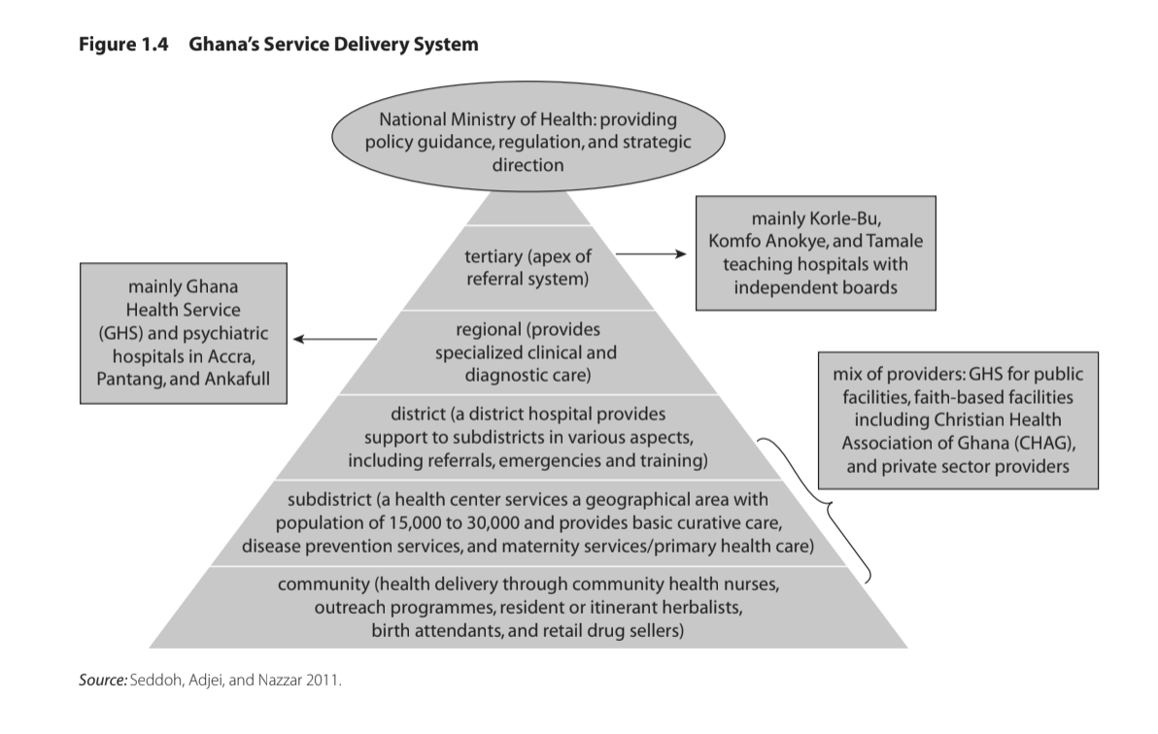
Reference: Cashin C, Saleh K, Lavado R. Health Financing in Ghana.; 2012. doi:10.1596/978-0-8213-9566-0

Annex B. Health Centre Staff Interview Summary

Interview with Health Centre Staff in Akyem Dwenase
Interview over WhatsApp video call with clinic staff (n=4) • Date: May 22, 2019

- The clinic has existed since 1995.
- Most of the clinic staff has worked at the clinic for the last four years.
- The services offered at the clinic include obstetric services, antenatal services, reproductive services, family planning services, adolescent health, and home visits.
- The greatest strength of the clinic is that the staff works as a team. With the little equipment we have, we make sure that the patients benefit from what we have.
- Our main challenge is lack of privacy. Because we don’t have separate wings, we have three adult beds and one cot with adults of different genders and children mixed together.
- In a year from now, we would like our clinic to have a capacity of 19-20 people, and we would like the mothers to feel comfortable at the clinic.
- Increasing usage of the clinic is dependent on mother’s having a positive, dignified experience in labor.
- Another challenge with transportation occurs during the rainy season. When a flood happens, clients cannot access the clinic.
- Most of the women give birth in the clinic, but if the road is flooded, then some of them can’t make it to the clinic in-time.
- Most of the women come to the clinic by taxi, motorcycle / bike, or some walk.
- The staff reported providing 24 hour service when necessary at the clinic, for which they do not receive overtime pay or additional benefits.
- Some of the staff also live up to 20 km away from the facility, and there is nowhere at the facility for them to stay or live.
- The maternity ward currently has one delivery bed, two maternity beds, a mosquito net. The room is very small.
- Some equipment that the facility does not have but needs includes: a nebulizer for asthma situations, increased delivery beds, a sterilizer, and oxygen.
- Family planning occurs in a variety of ways – oral, implants, and some natural.
- The District Hospital is 15 kilometers away.
- Medication shortages sometimes include antibiotics, antimalarials.
- Number of patients at the hospital varies by season. In the rainy season, usage increases due to malaria, anemia, and snake bikes which are seasonal.
- Average daily number of patients is 20 to 30.
- Average weekly number of pregnant people is 10 to 15.
- The health workers do a variety of community health education projects – a pregnancy school, camp, home visit, churches.
- We are interested in trainings for managing emergency cases, HIV cases.
- We have heard about the World Vision Foundation doing work in the Eastern Region, but no other NGOs active in the area.

Annex C. Survey of Health Centre Staff

Survey of Clinic Staff Health Centre in Akyem Dwenase
Survey sent to clinic staff (n=2) • Responses received May 24, 2019

Which of the following goals are the most important to you?
(1: most important, 4: least important)

- Improve facility infrastructure (number of beds, privacy, medications, equipment)
- Improve capacity of health center to provide adequate OB care
- Increase utilization of services by mothers in community
- Reduce time to arrive at health facilities (travel to your clinic and district hospital)

In regards to facility infrastructure, which goals are most important to you?
(1: most important, 5: least important)

- Increasing number of beds
- Increasing privacy within the center
- Increasing supply of medication
- Adding equipment
- Developing a better system for medical records

Do you have the following medicines/equipment at the clinic to provide obstetric care?

Medicines/equipment that are currently available:

- Partograph
- Oral antibiotics
- Oxytocin, misoprostol
- Magnesium sulfate
- Forceps

Machines/equipment that the clinic lacks:

- Hand-held, portable ultrasound
- Doppler ultrasound
- Fetal heart rate doppler
- Fetal heart rate stethoscope
- Manual vacuum

Which of the following emergency obstetric care services can you currently provide?

Emergency obstetric care services that the clinic can provide:

- Administer antibiotics
- Administer parenteral oxytocin, Ergometric, or misoprostol
- Administer magnesium sulfate for preeclampsia and eclampsia
- Manually remove the placenta
- Perform basic neonatal resuscitation with bag and mask

Emergency obstetric care services that the clinic is not currently able to provide:
- Perform manual vacuum extraction, dilation, and curettage
- Perform assisted vaginal delivery with vacuum extraction, forceps delivery
- Perform caesarean section
- Perform blood transfusion

The district hospital is able to provide all nine of these comprehensive emergency services.

How many beds do you think the clinic needs overall to meet the community demand?

- 40 beds

How many delivery beds do you think the clinic needs to meet the community demand?

- 3 delivery beds

How many mothers did you refer to the District Hospital last year due to complications?

- On average, 20 per year

If the clinic infrastructure expanded, do you think the Ministry of Health will provide additional staff?

- Yes

Could you describe the current record-keeping system at the clinic?

- We use folders and files for health records of patients at the clinic.

What improvements should be made to the record-keeping system?

- Electronic system (using paperless method for proper keeping of patient records)

Have you seen or heard about telemedicine used in rural communities in Ghana?

- We have heard about it, but we have not been trained on it.

Have you seen or heard about mobile clinics used in rural communities in Ghana?

- We normally go in a taxi to nearby villages for medical outreach services.

How do you receive medical supplies at the clinic? How far away is the district supply store? If the district supply store runs out, where could you get medical supplies?

- We received medical supplies from the regional medical store, which is 61 km away. Last-mile distribution (LMD) is made to the doorstep of the clinic.
- We wait three months before they supply again.

Where specifically do patients encounter problems with accessing the clinic?

- The road specifically leading to the clinic is often flooded.
- The path leading to the clinic once on the property has a risk for snake bites.

Annex D. GANTT Chart

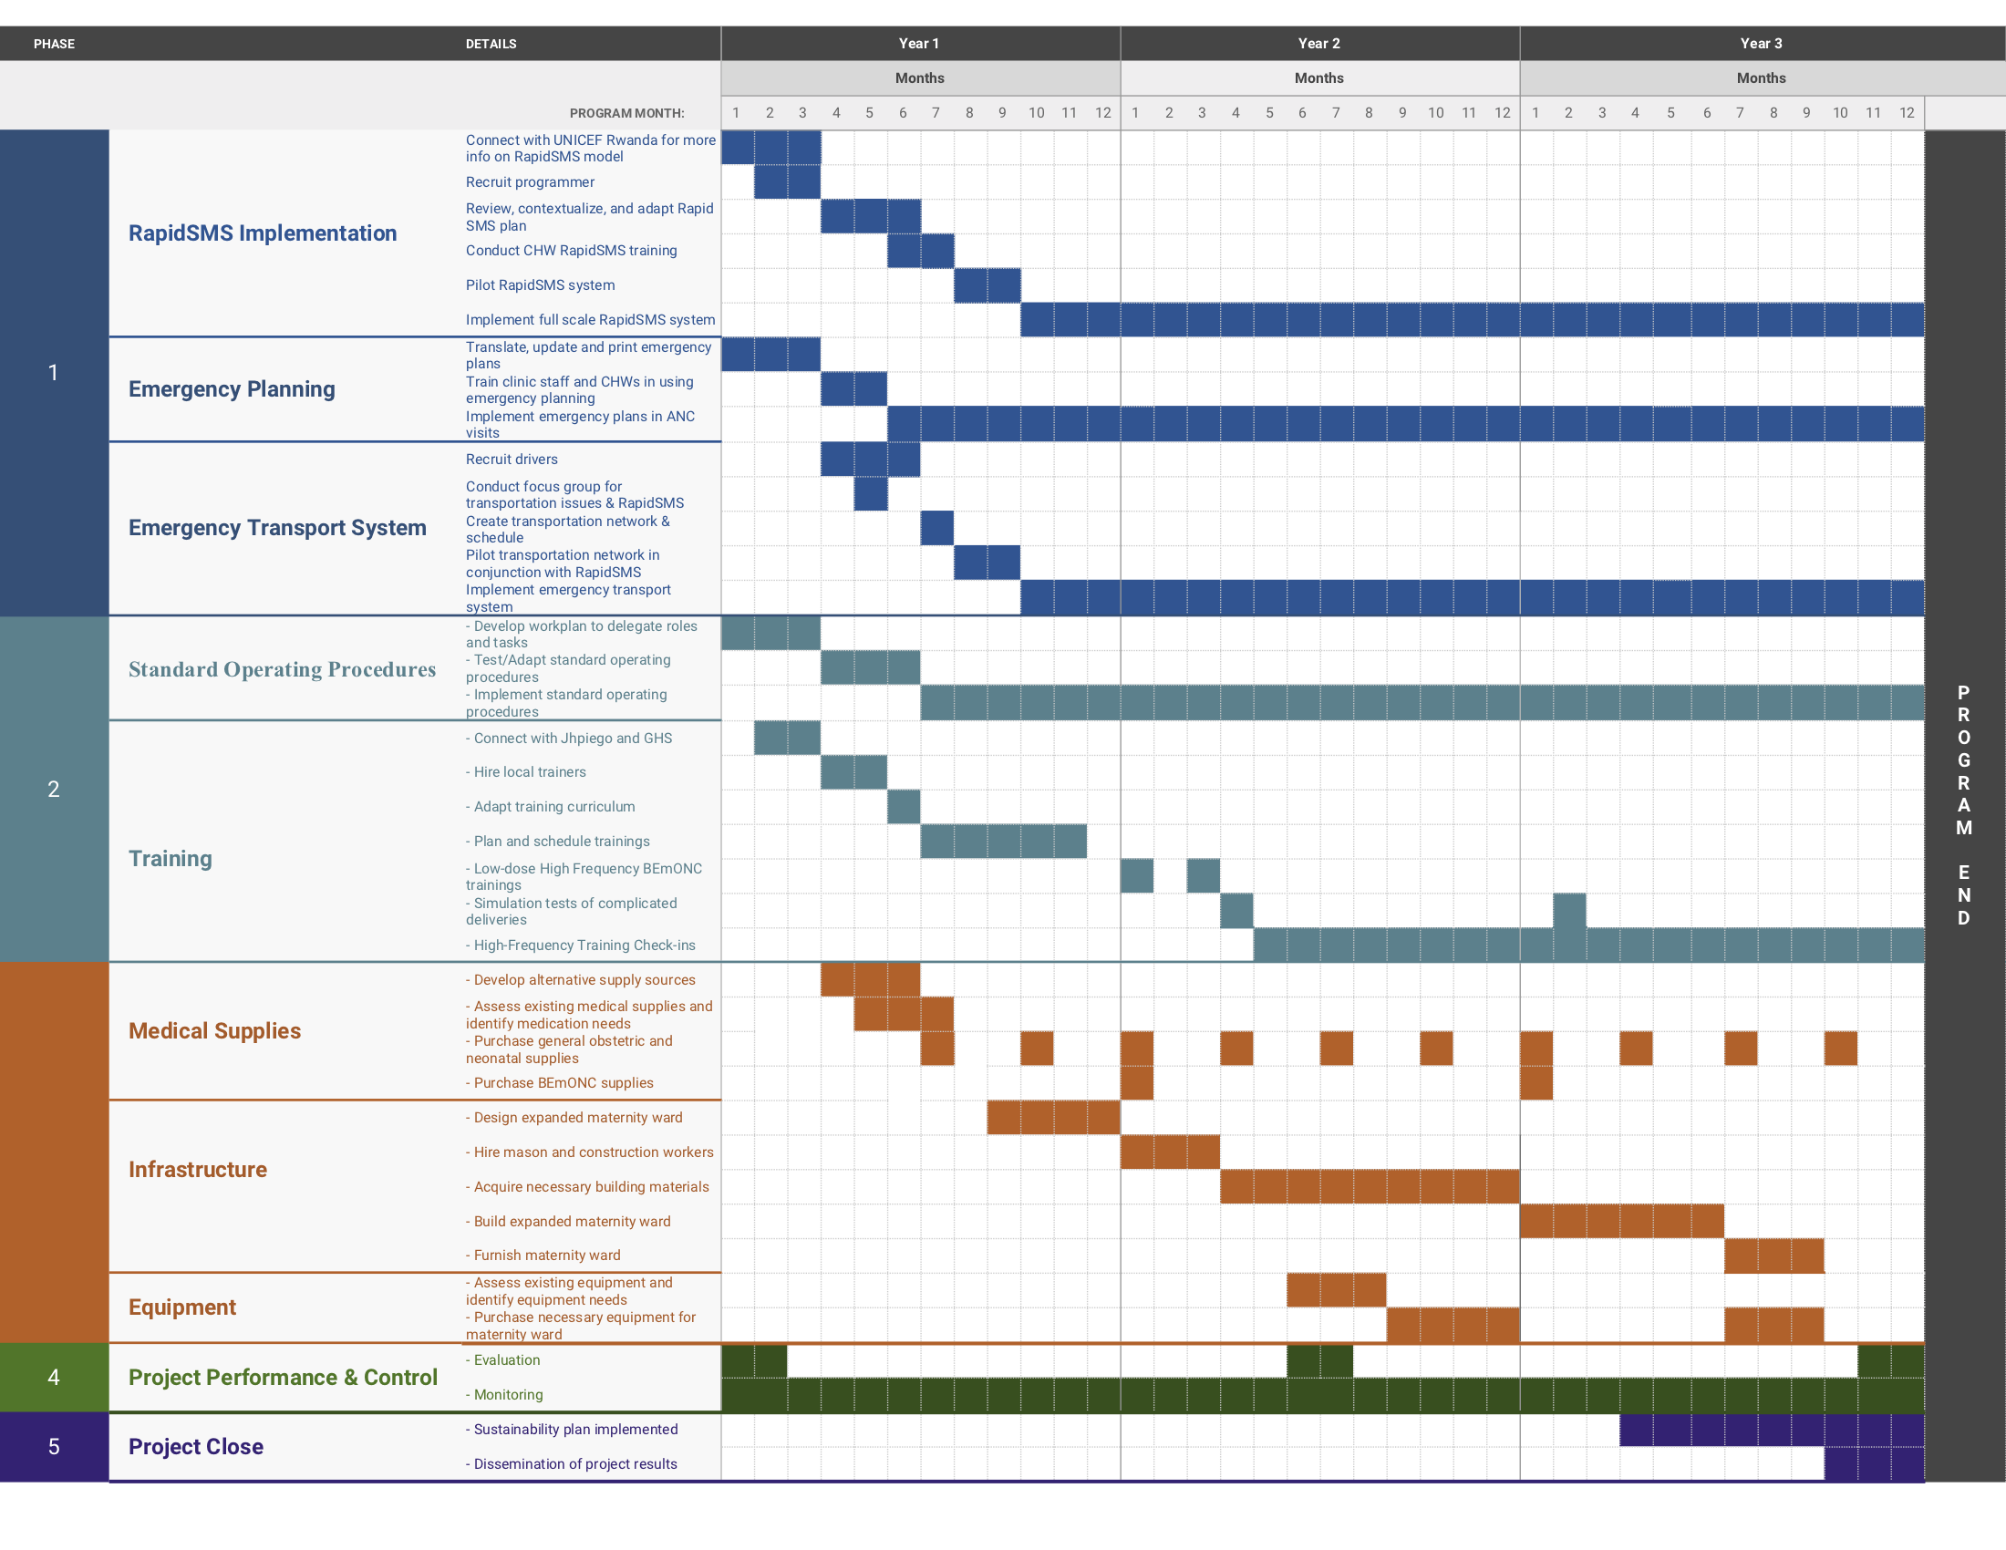
Annex E. Monitoring and Evaluating Indicators
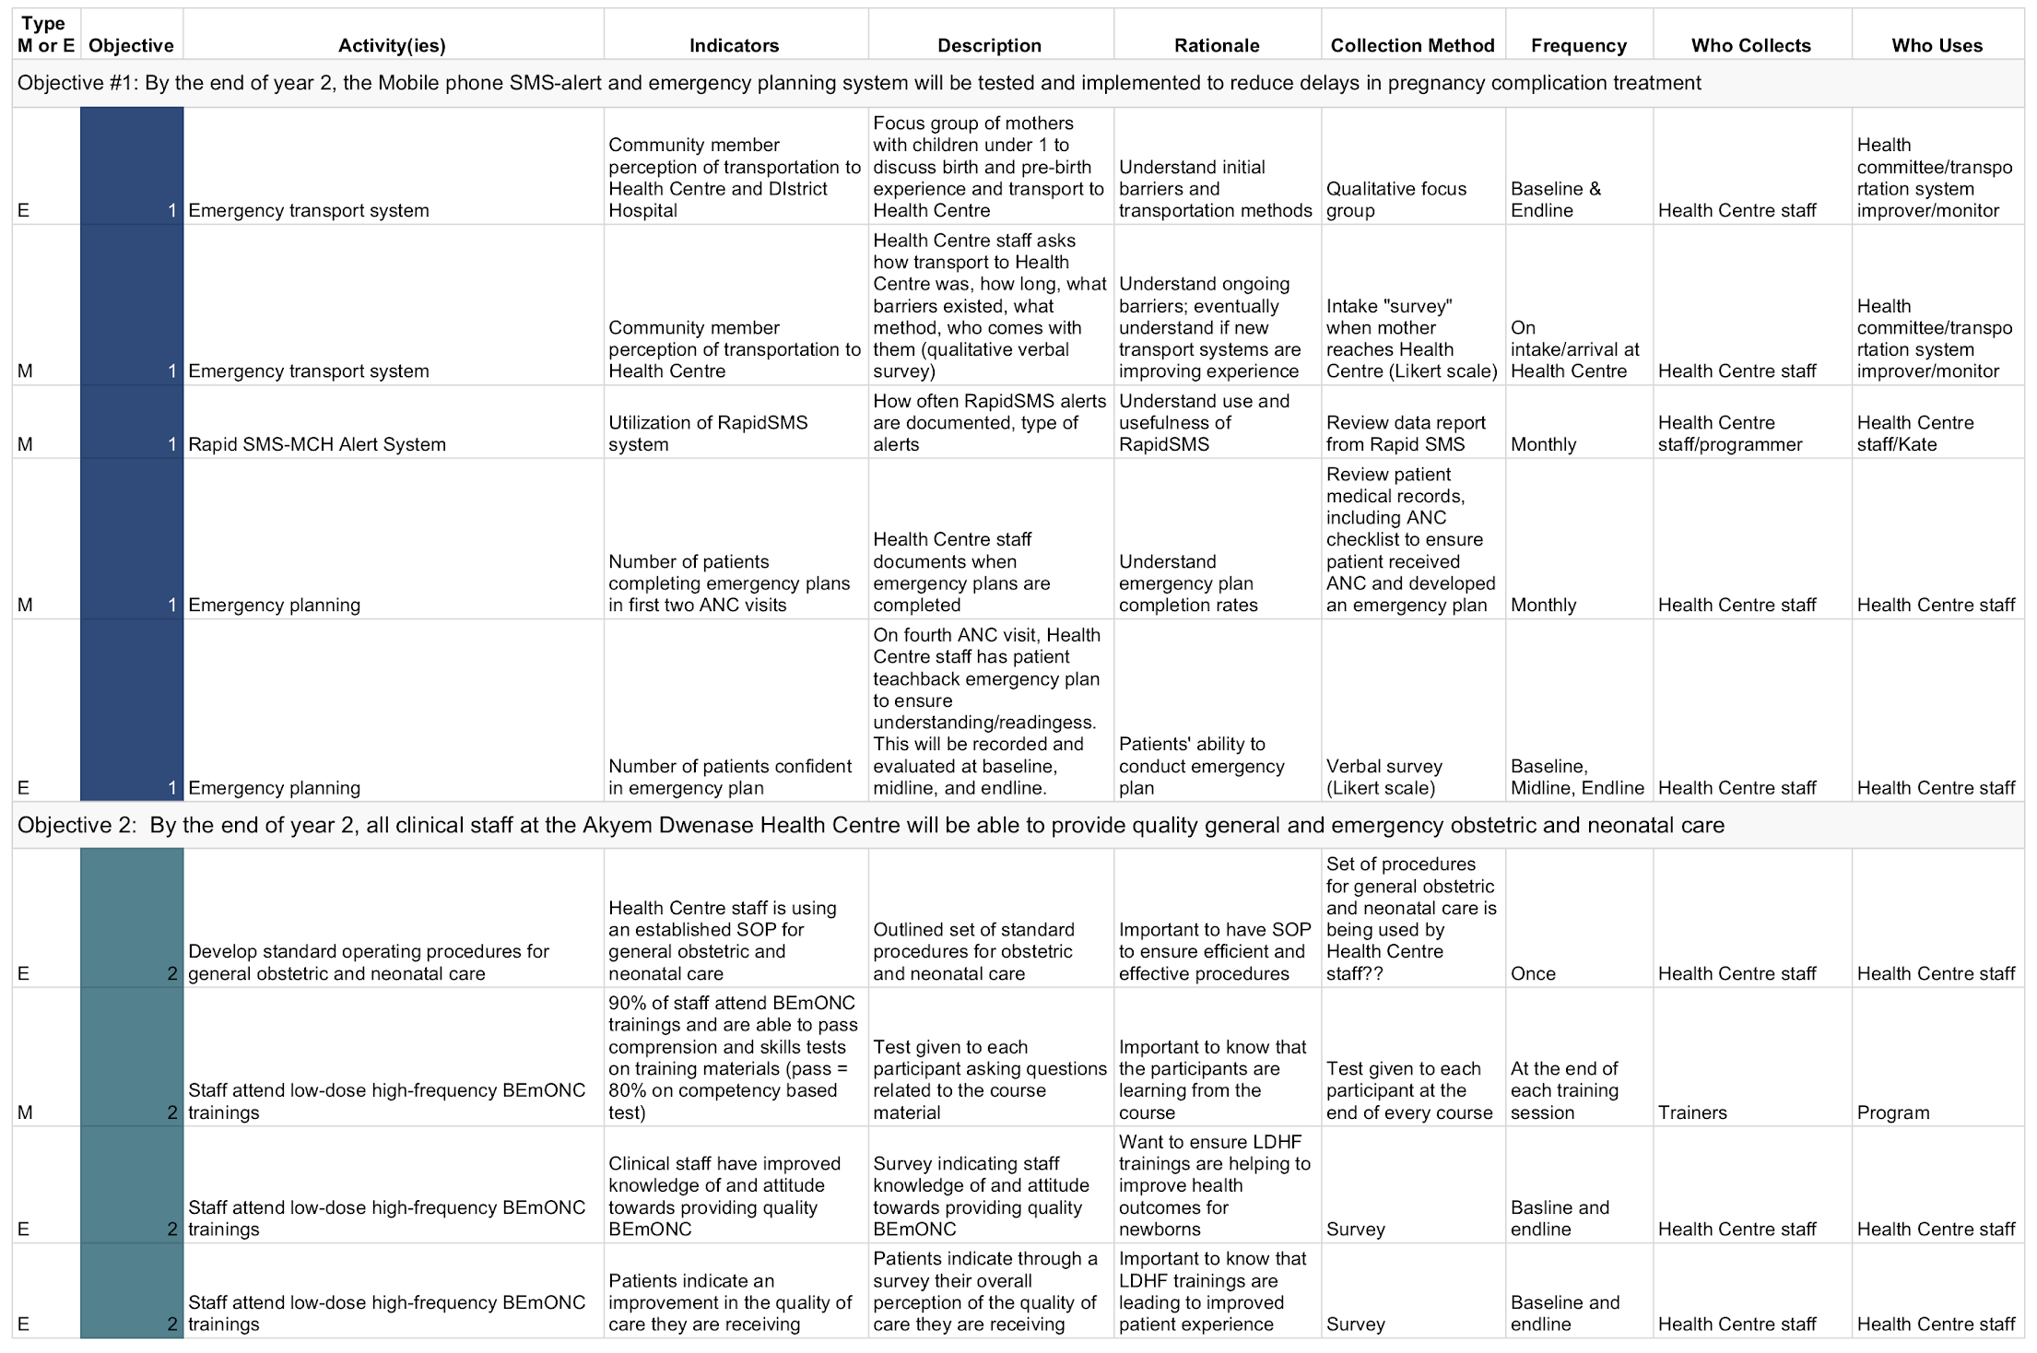

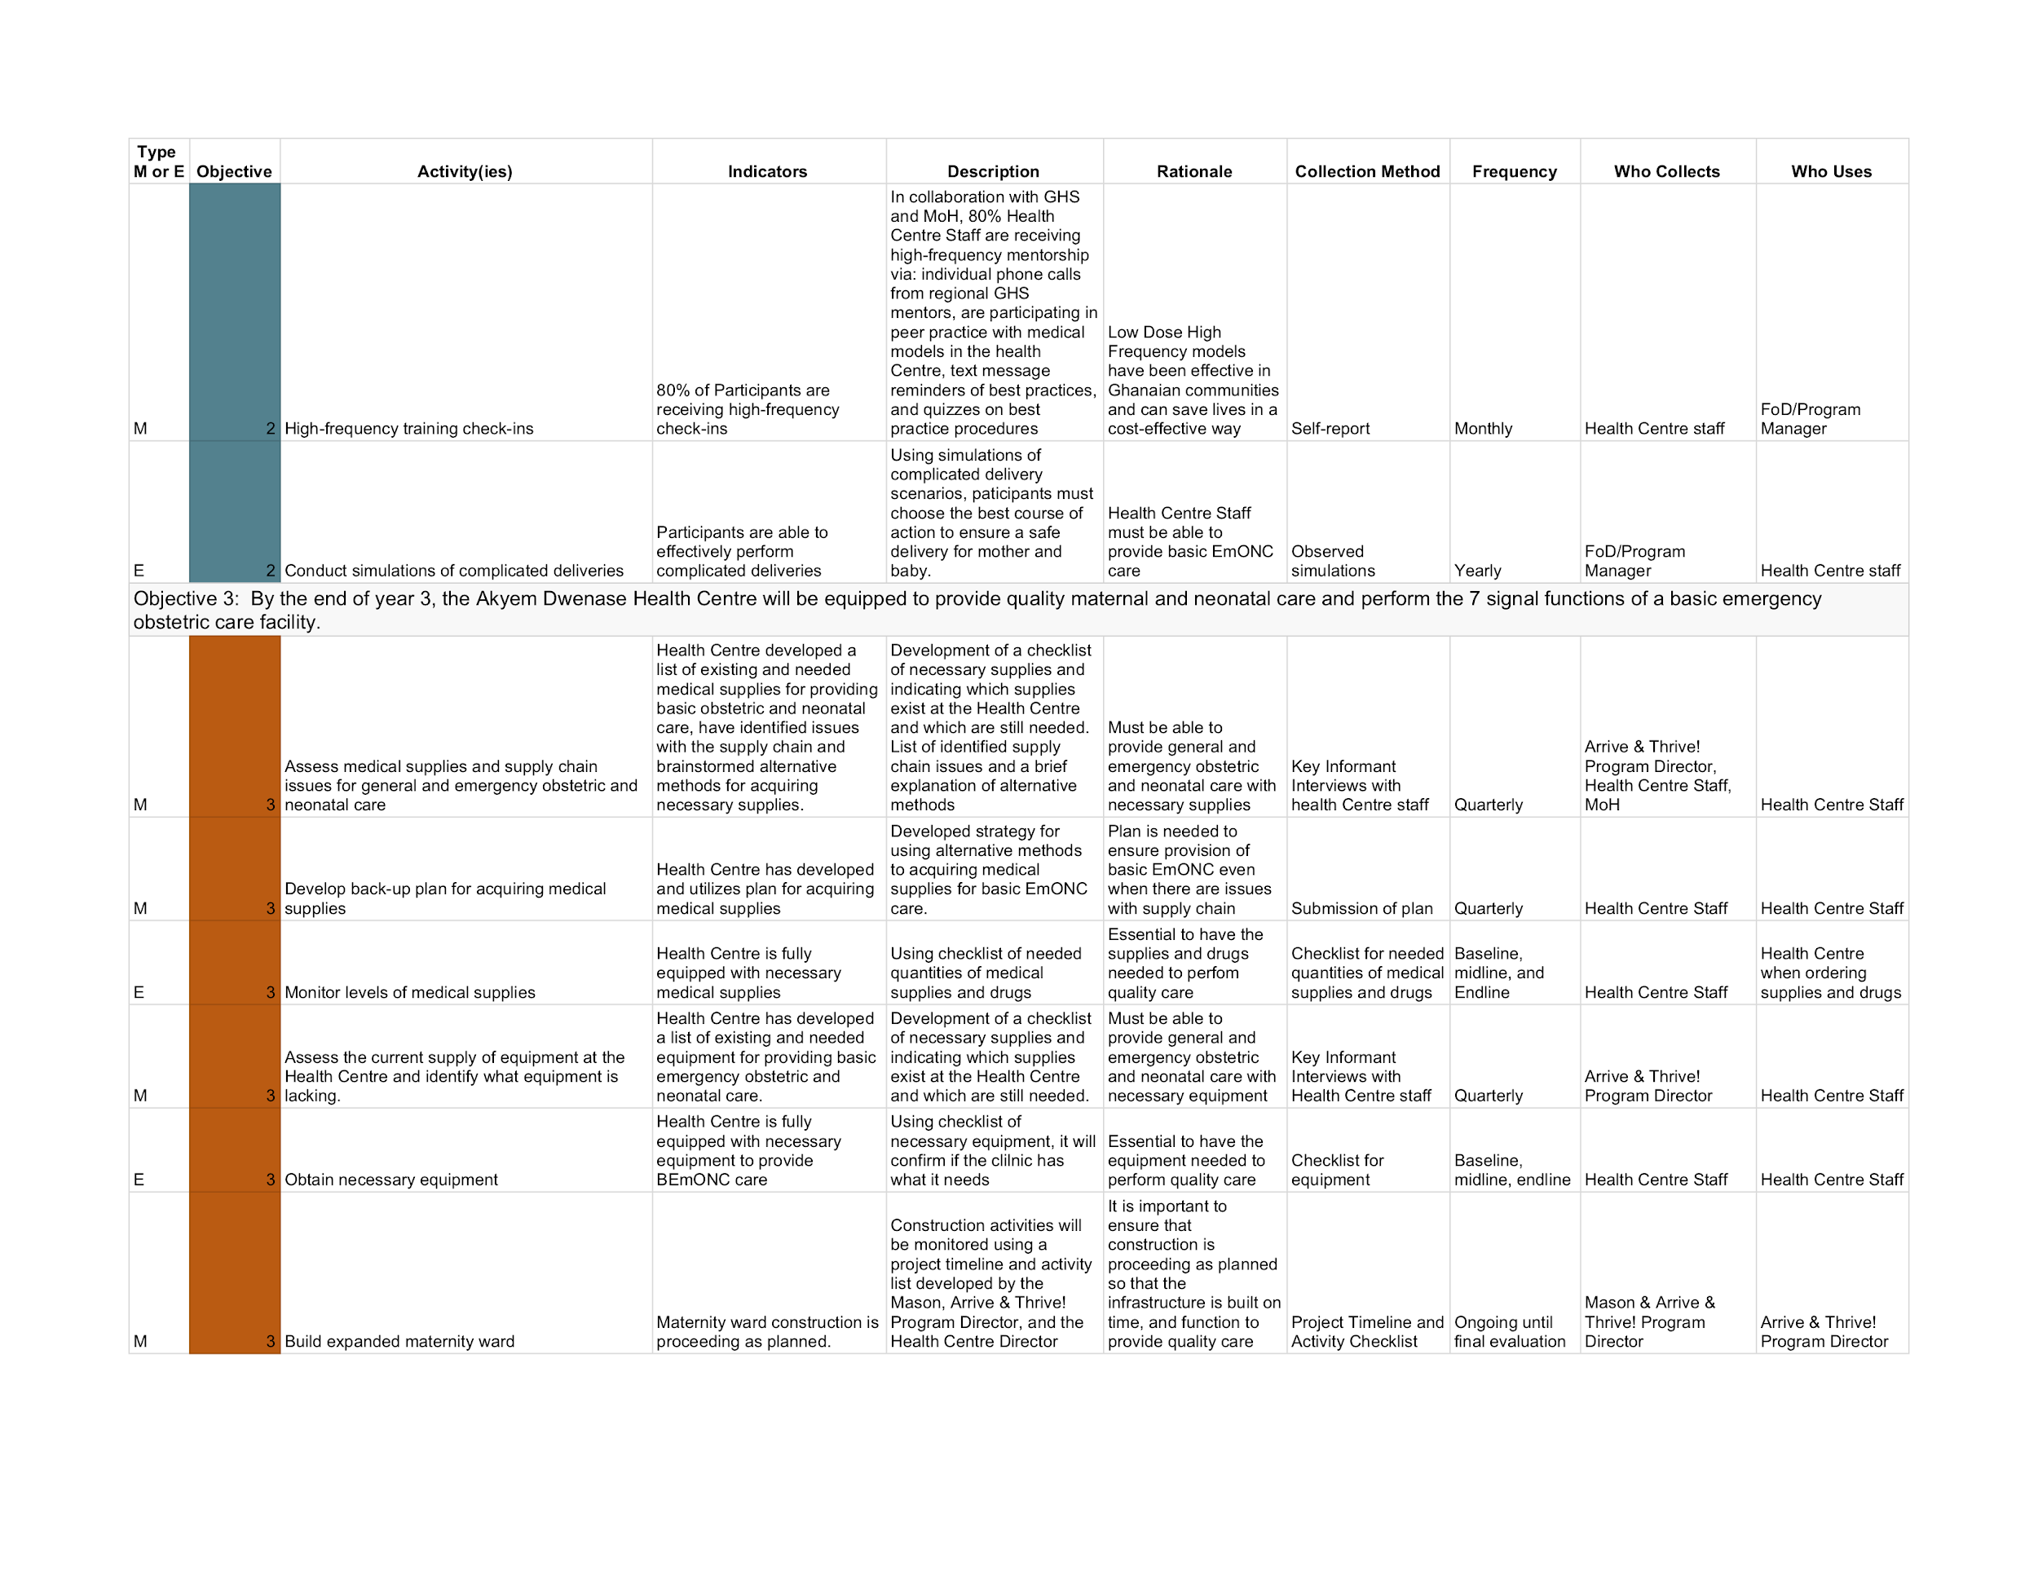

Annex F. LDHF BeMONC Training Program

Rationale
The LDHF Training model is a cost-effective competency-based training model that takes place in the implementing health facility -- for our purposes, the Akyem Dwenase Health Centre. This approach will better enhance the Health Centre workforce capacity, sustain knowledge and skills gained through training, and help learners translate lessons into their daily clinical practice. LDHF operates with small quantities of content, frequent repetition, and participatory simulation-based practice that keeps providers in their clinical environment while learning. This model has been successfully implemented in Mozambique, Uganda, Ghana, Rwanda, Ethiopia, Zambia and has also been applied to programs in the United States.

To implement this training model in Akyem Dwenase, we envision that the training program will consist of 3 Phases:

Phase 1: Development
Referencing the LDHF training program recently implemented in Ghana, Director of the Akyem Dwenase Health Centre (who is employed by the MoH) will plan the LDHF training program with two Ghanaian LDHF trainers so as to not overlap with existing training programs. The LDHF Trainers will adapt the curriculum to the Akyem Dwenase Health Centre context.

Phase 2: Startup
The Director of the Health Centre and the Arrive & Thrive! Program Director will work with the LDHF Trainers to schedule and plan BEmONC trainings to occur onsite at the Akyem Dwenase Health Centre. The Arrive & Thrive! Program Director and the LDHF Trainer will identify existing MoH staff in other areas of Ghana who have successfully participated in LDHF training programs to act as mentors for the Akyem Dwenase trainees.

Phase 3: Implementation
Two, 4-day low-dose trainings on BEmONC will be provided at the Akyem Dwenase Health Centre using clinical simulation-based practice with models, mentorship, and coaching. Trainees in the program include the Health Centre clinical staff and CHWs who provide labor, delivery, and immediate postpartum care. The first training session (LDHF1) will take place in Month 1 of Year 1, and will focus on basic maternal and neonatal care. The second training (LDHF2) will take place one month after LDHF1 and will cover emergency and delivery complications for maternal and neonatal care. Following these training sessions, content is reinforced through high-frequency mentorship including individual phone calls and text messages between trainees and existing MoH mentors. The Arrive & Thrive! Program will provide financial support for mentorship calls and messages, and a small stipend for mentors to ensure that the mentorship activities are completed. Lodging and food will also be provided for Trainers during the 4 day training periods, as well as meals.

Monitoring
The Director of the Health Centre will report to the Arrive & Thrive Program Director that Health Centre staff are continuing to practice what they have learned, and that trainees are receiving mentorship calls.

Annex G. Budget
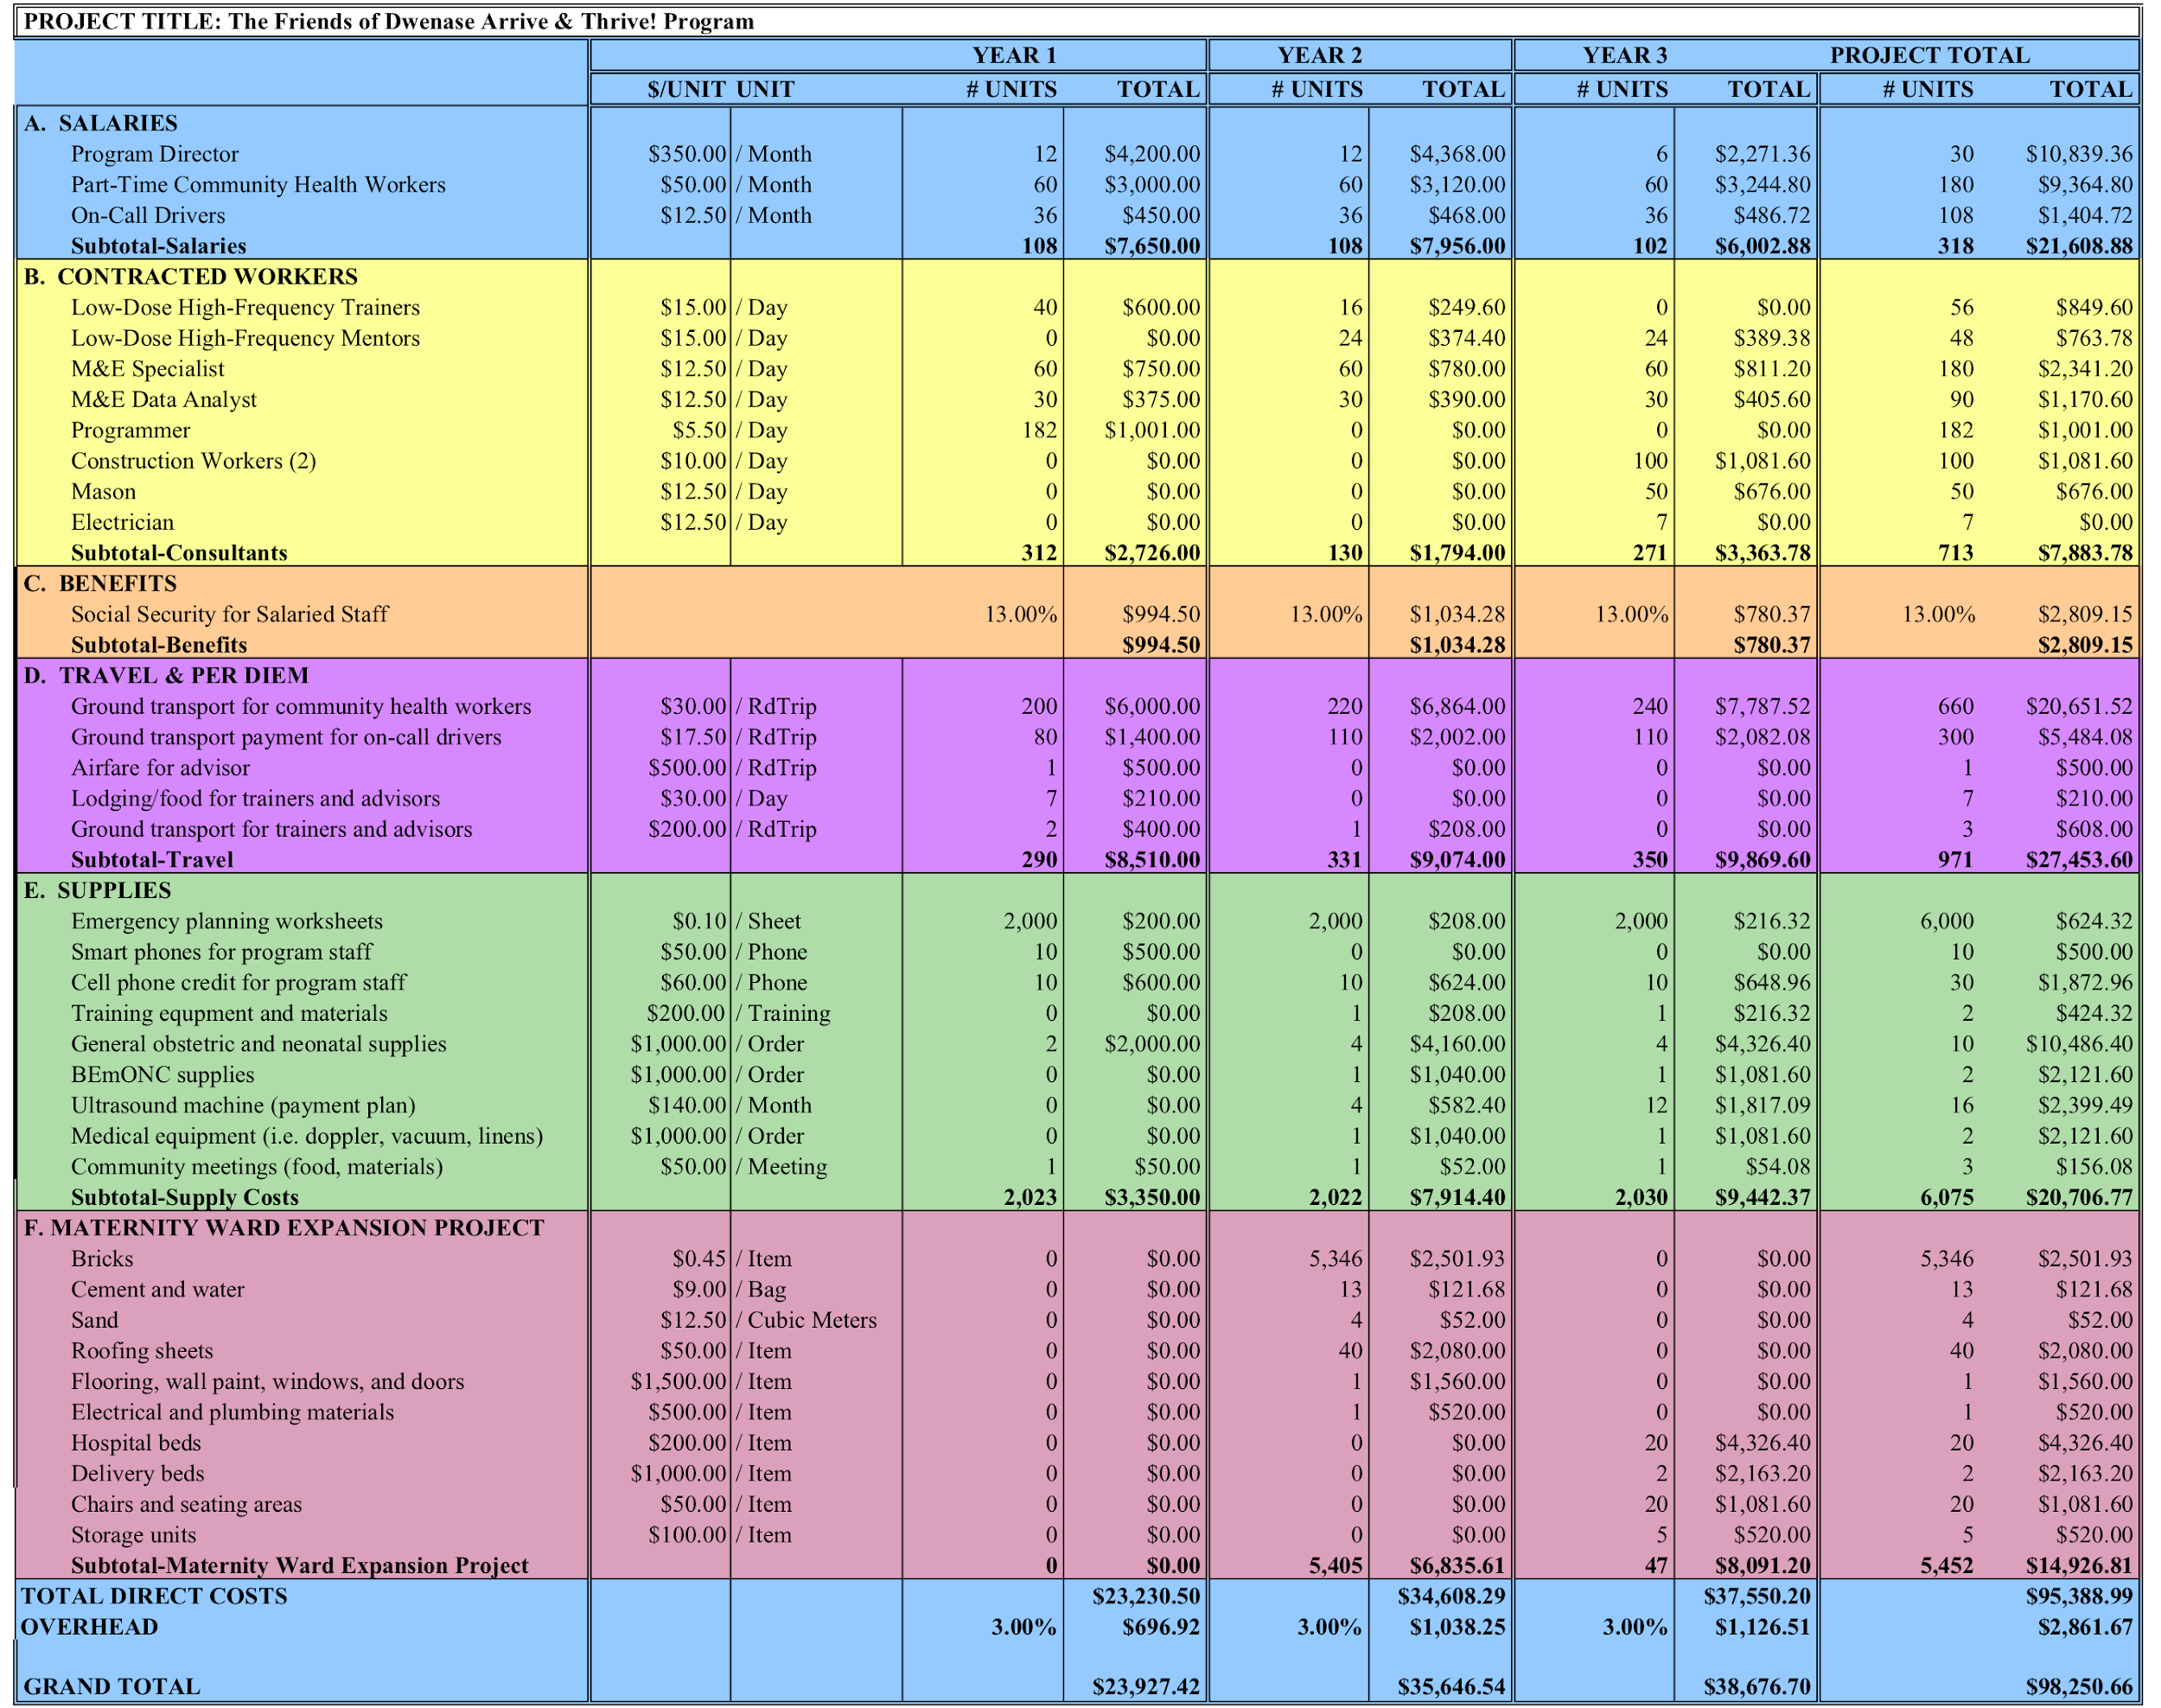
Annex H. Budget Justification

- Salaries.……………………………………………………………………………....………..Total: $21,609.88

Program Director will be hired to manage the M&E Staff, Rapid SMS-MCH Programmer, and the Mason to build the expanded maternity ward. The Director’s salary will be $4,200 per year and will be covered for 3 years of the program. Currently, there is no management in place for the Arrive & Thrive! Program, this position is critical to ensuring program success.

Part Time CHWs are needed to assist with implementation of emergency planning, patient outreach and education, and assisting with BEmONC. Part Time CHWs will be paid $50 per month throughout the duration of the program.

Drivers are critical to implementing the Emergency Transport System. By paying Drivers for committing to their on-call periods and driving time and providing funding for gasoline, we will ensure that drivers will be available and prepared to respond promptly and provide safe transportation for mothers.

B. Contracted Workers.……………………………………………………………………………...Total: $7,883.78

LDHF Trainers are essential to ensuring that the training model is successful in increasing the capacity of the Health Centre staff and CHWs who provide labor, delivery, and immediate postpartum care. The trainers will earn a daily rate of $15 and will be contracted for 1 month in Year 1 to adapt the training curriculum to the local context, and when training begins in Year 2, Trainers will be compensated for the two 4-day training periods, including their travel, lodging, and meal costs.

LDHF Mentors will be existing MoH clinical staff at comparable villages in Ghana who have already been trained in BEmONC using the LDHF training model. Their primary role is to provide mentorship through frequent check-ins with their assigned staff members in the Akyem Dwenase Health Centre and the CHWs in the Akyem Dwenase community. To facilitate this mentorship, the Mentors will be provided a stipend for their time, and the Arrive & Thrive! Program will provide financial support for calls and messages sent between Mentors and Trainees.

M&E Specialist and Data Analyst will be hired at a daily rate of $12.50. The Technical Staff will collect qualitative and quantitative data at baseline, midline, and endline. The Data Analyst will organize, code, and analyze the collected data. Together with the Arrive & Thrive! Program Director, the M&E Staff and Data Analyst will develop and disseminate evaluation reports to stakeholders and the public.

Programmer will be essential to developing the Rapid SMS-MCH Alert System. This person will be paid a daily rate of $5.50. The programmer will review and update the Rapid SMS scripts taken from the original Rwandan program, advise on adequate cell phones for the program, and train Health Centre staff and CHWs in using the Rapid SMS-MCH Alert System.

Mason will be hired at a rate of $12.50 per day and will be responsible for incorporating patient, community, and Health Centre input on the design of the new maternity ward infrastructure. The Mason will also directly manage the Construction Workers and the Electrician.

Construction Workers will be hired at a rate of $10.00 per day beginning in Year 3. The construction workers are critical to building the new maternity ward and directing Community Volunteers as needed.

Electrician will be employed at a rate of $12.50 per day and will ensure that the new maternity ward is equipped with necessary electrical wiring, outlets and power connectivity. The electrician will also be responsible for directing Community Volunteers as needed to complete basic electrical work.

C. Benefits.………………………………………………………………………………………………Total: $2,809.15
Social security will be paid for all salaried staff, which amounts to 13% of each yearly salary.

D. Travel & Per Diem…….……………………………………………………………………….......Total: $27,453.60
The staff is expected to travel within the Eastern Region of Ghana, and some staff will be expected to travel internationally for Rapid SMS-MCH Alert System development.

E. Other………………….…………………………………………………………………………..….Total: $20,706.77
Emergency Planning Worksheets……………………………….$624.32
Cell Phone Costs for Rapid SMS-MCH Implementation……...$2,372.96
Training Equipment and Materials……………………………....$424.32
General Obstetric and Neonatal Supplies……………………...$10,486.40
BEmONC Supplies………………………………………………..$2,121.60
Ultrasound Machine………………………………………………$2,399.49
Medical Equipment………………………………………………..$2,121.60
Community Meetings……………………………………………..$156.08

F. Maternity Ward Expansion Project….....………………….……………………………..……..Total: $14,926.81
The Akyem Dwenase Health Centre Staff have expressed a need to build an expanded maternity ward to better serve the mothers of the greater Akyem Dwenase population.
Construction Supplies……………………………………………$6,315.61
Maternity Ward Equipment……………………………………...$8,611.20

Total: $98,250.66

Annex I. Recommendations for Funding Strategy
Steps Necessary Prior to Funding
- Name board members for the Friends of Dwenase NGO in Ghana.
- Register NGO in Ghana.
- Identify a non-profit organization with 501c3 status with a similar mission who could act as a fiscal sponsor in the United States and accept donations on behalf of the NGO. (If you choose to incorporate a non-profit organization in the United States, you will need to name a separate board of directors, register in a state of your choice, apply for 501c3 exempt status, and wait to receive the 501c3 status to receive funding).
Diverse Funding Streams
- To kick off funding for the first year, we recommend that you host a fundraising event using your network of project supporters in the United States and around the world. This will allow you to launch your first activities and develop a track-record as an organization that will enable other funding sources.
- As the program continues to expand, corporate social responsibility partnerships can be secured with banks and other companies in Ghana who are looking for free publicity by taking positive social actions. Partners can have their logos represented in project materials and on taxis or posters involved in program.
- For equipment and supplies, there are a number of foundations and grants that exist exclusively to buy medical supplies and equipment for organization. The Ambassador’s Small Grant Program at the U.S. Embassy and the Medical Credit Fund are two potential grants.
- For long-term sustainability, community support for the transportation program and to cover medical supply expenses will be necessary. Additional funding may also be secured from the MoH in the long-term once the clinic expands and serves more patients. Alternatively, the Health Committee can take over fundraising activities locally, relying on community connections and past corporate partners.

Annex J. External Review Feedback
Feedback on Proposal Presentation from External Reviewers
On May 31, 2019, our team of consultants presented the Arrive & Thrive! Program proposal to an external review panel including David M. Barash, MD, Lynn Black, MD, MPH, and Robert Cushman, MD, MS, MBA, and audience members including program stakeholders, BU faculty, and fellow GH744 consultants. The feedback received from the review panel and the audience included the following:
- Maternity Waiting Homes: Maternity waiting homes have been successful interventions in many countries to ensure that mothers defined as “high risk” can await their delivery at a nearby health facility shortly before delivery, or earlier in the case of complications. Adding a maternity waiting home to the maternity ward construction project could further increase access to quality health care and mitigate the risks of not being able to find emergency transport.
- Clean Delivery Kits: Equipping expectant mothers with Clean Delivery Kits is a simple solution to increasing safe deliveries and motivating our emergency transport drivers to be a part of the emergency transport network. Included in the Clean Delivery Kit, a simple plastic sheet will create a safe birth area while keeping the vehicle clean, and soap and gloves will help mitigate any infections.
- Long-Term Benefits: A benefit of this program that we did not stress very much in the presentation but is an important long-term impact of this works is reductions in morbidity and disability. Keeping mothers and newborns alive is the major goal of this program, but equally important, is helping mothers and newborns stay healthy so that they can contribute to the development of the community and country.
- Organization of Budget: When presenting this budget to funders, it should be reorganized by objective, so that the total cost of each objective is presented individually. For example, it would be useful to present the overall cost of the Community Health Workers Program. In the budget, travel and per-diem costs should be classified under the label of “Operational Costs.”
Contacts for Continued Program Development
To continue development of this program with resources and support from Boston University School of Public Health and Boston University, we recommend connecting with the following individuals:
- Professors/researchers at BUSPH with relevant expertise:
  - Richard Laing (attended presentation) (https://www.bu.edu/sph/profile/richard-laing/)
  - Nancy Scott (expert on maternity waiting homes) (https://www.bu.edu/sph/profile/nancy-scott/)
- BUSPH practicum office to identify a student who could continue working on project development as an internship for their semester-long practicum to fulfill their MPH program requirements:
  - Julia Lanham (https://www.bu.edu/sph/profile/julia-lanham/)
- Innovate@BU’s BUild Lab offers events and expert office hours to provide feedback on budgets, sustainability, and fundraising to students, staff, and faculty designing projects that create social impact:
- Blake Sims (https://www.bu.edu/innovate/profile/blake-sims/)

