RHD RED Mobile Phone Application User Guide

Our team is working with Dr. Amy Sanyahumbi, a pediatric cardiologist, in Malawi to create a remote-entry data capture registry for patients with rheumatic heart disease (RHD). Exposure to streptococcal pharyngitis leads to acute rheumatic fever resulting in cardiac valve damage that causes RHD. High prevalence of RHD leads to cardiac morbidity and mortality. Approximately 300 million people are affected worldwide and 275 thousand die per year. Monthly injections of Benzathine Penicillin G (BPG) has been proven effective to prevent severe RHD.

Our goal is to create a registry that will allow Dr. Sanyahumbi and local health workers in Malawi keep an accurate, up-to-date record of youth who have RHD and connect them to appropriate resources to ensure that they do not develop further strep throat or severe RHD. We want to improve the surveillance of RHD among youth in rural and urban Malawi and ensure that those individuals who are registered in the application are receiving their monthly injections of BPG (every 28 days). Those who will use the application are Dr. Sanyahumbi, nurses, medical assistants, and local health workers.

Instructions: Register a new patient and fill out each form during the appropriate time.

We have broken down the application into 6 different forms; 1) Registration, 2) RHD Follow-Up, 3) BPG Follow-Up, 4) Adverse Event Form, 5) Questions for Cardiologist, and 6) Annual Visit/Echo.
- The registration form will be used to register patients with RHD.
- The RHD Follow-Up form is filled out every three months by Dr. Sanyahumbi at the Kamuzu central hospital.
- The BPG Follow-Up form is filled out by either Dr. Sanyahumbi, a nurse, medical assistant, or local health workers every month when the patient visits either the Kamuzu central hospital or their local health center to receive their BPG injection.
- The Adverse Event Form is filled out when an adverse event, transfer of care, or death has occurred. If the patient has passed, the case will automatically close.
- The Questions for Cardiologist form will be filled out by local health workers at local health centers when they have questions for Dr. Sanyahumbi. This form also includes a label of frequently asked questions and answers.
- Patients with RHD are required to visit Dr. Sanyahumbi annually to follow-up with their RHD. If it has been a year since the patient’s echo, an echo is ordered and the Annual Visit/Echo form will be filled out during this annual visit.

Download information: Using the CommCare application on an Android device, please download our app by scanning the barcode below or clicking the link and entering code below.

LINK:
https://www.commcarehq.org/a/rhd-red/apps/download/2c774b4aeac74e58960a751a0cfb5af6/media_profile.ccpr?profile=

APP CODE:
2VO0Pkz

BARCODE:
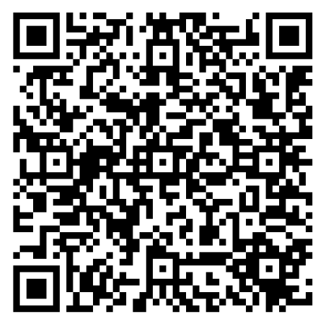

Click here to access and download the video tutorial on how to navigate the RHD RED App.

Downloading Data: To download data from the RHD RED App, click on the “Data” tab on the top navigation bar and select “Export Form Data” or “Export Case Data” There are 6 form-specific data reports and 1 case summary report that can be downloaded into Excel:

Form Specific:
- RHDRED_AdverseEvents
- RHDRED_AnnualVisitEcho
- RHDRED_BPGFollowUp
- RHDRED_QuestionsForCardiologist
- RHDRED_RHDFollowUp
- RHDRED_Registration
Case Summary:
- RHDRED_CaseSummary

Find the form you would like to export in the list and click the “Export” button. This will bring you to a page where you can specify the date range of data you would like to download. Enter your desired date range and click the “Prepare Export” button.

To export multiple forms at once, check the boxes under the “Bulk Export” column next to the form names that you would like to export, or click the “All” button in the column header to export all forms on the list. Select the desired dates as above and click the “Prepare Export” button.

Once the data has downloaded, you can open the file in Excel to view and analyze the report.

